Contents

Pass Borderline Task 1 1

Pass Borderline Task 2 4

Pass Borderline Task 3&4 10

Pass Borderline Task 5 14

Pass Borderline Task 6 17

Pass Plus Task 22

Credit Task 23

Distinction Task 24

High Distinction Task 25

# Pass Borderline Task 1

Q1. Briefly describe what is the different between the **void setup ()**, the **void loop ()** and the **main ()** function?

*In C/C++ main is the entry point of the program. It is the function that is called when the application is started, and all other functions are called from there. In Arduino Programming language, the main function is not available. Instead, we have the setup and loop functions. Setup is called once at the start. It is used to set up all the program such as setting the input and output pins. Loop is called repeatedly. It is where the crux of the code is.*

Q2. Write a program that will display your name and the ID number once in the serial monitor

*void setup() {*

*// put your setup code here, to run once:*

*Serial.begin(9600);*

*Serial.println("Faisal - 103603923");*

*}*

*void loop(){*

*}*

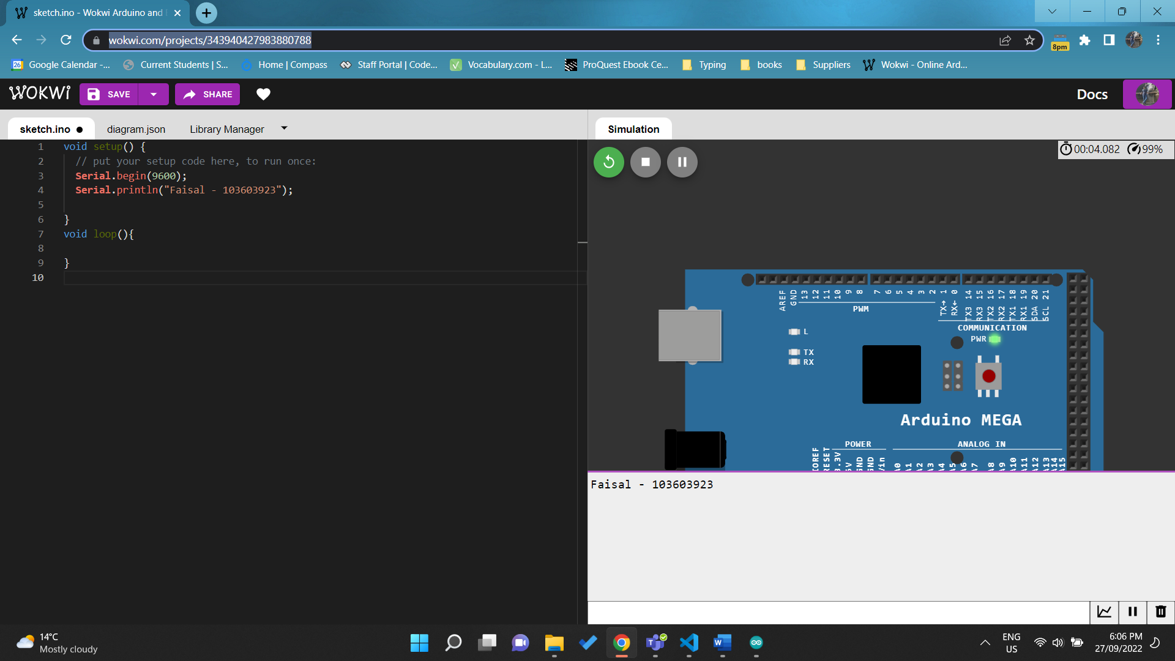

<https://wokwi.com/projects/343940427983880788>

Q3. Briefly describe the functions **delay (), Serial.println(), Serial.begin(), pinMode().**

*Delay(x) pauses the program for x number of milliseconds.*

*Serial.println(str) prints the input to the serial monitor*

*Serial.begin(rate) sets the baud rate. It is the rate at which the data is communicate to the serial in bits per second.*

*pinMode(pin, mode) sets the pin to either input or output mode.*

Q4. Write a program that will display the unit number and the unit's name at the beginning of the application and then repeatedly print (“Welcome to the lab session”) in every 2 seconds. (Require Demonstration)

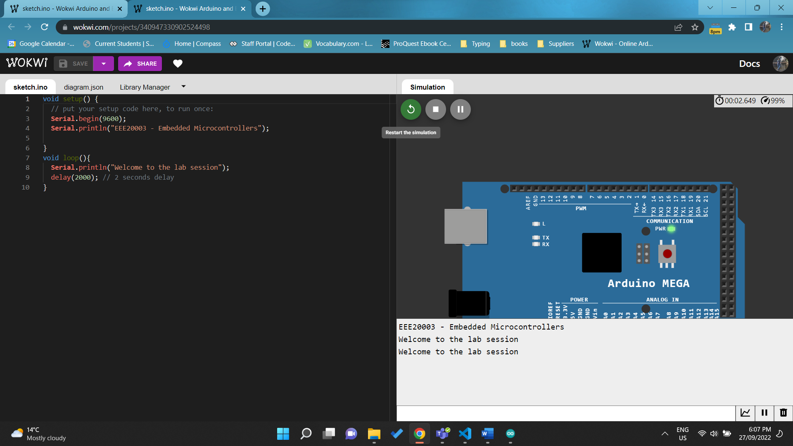

[*https://wokwi.com/projects/340947330902524498*](https://wokwi.com/projects/340947330902524498)

Q5. Write a program that will blink the inbuilt LED every 1 second.

void setup() {

**Serial**.begin(9600);

  pinMode(LED_BUILTIN, OUTPUT);

}

void loop(){

  digitalWrite(LED_BUILTIN, HIGH);

  delay(50); // 0.05 seconds

  digitalWrite(LED_BUILTIN, LOW);

  delay(1000); // 1 second

}

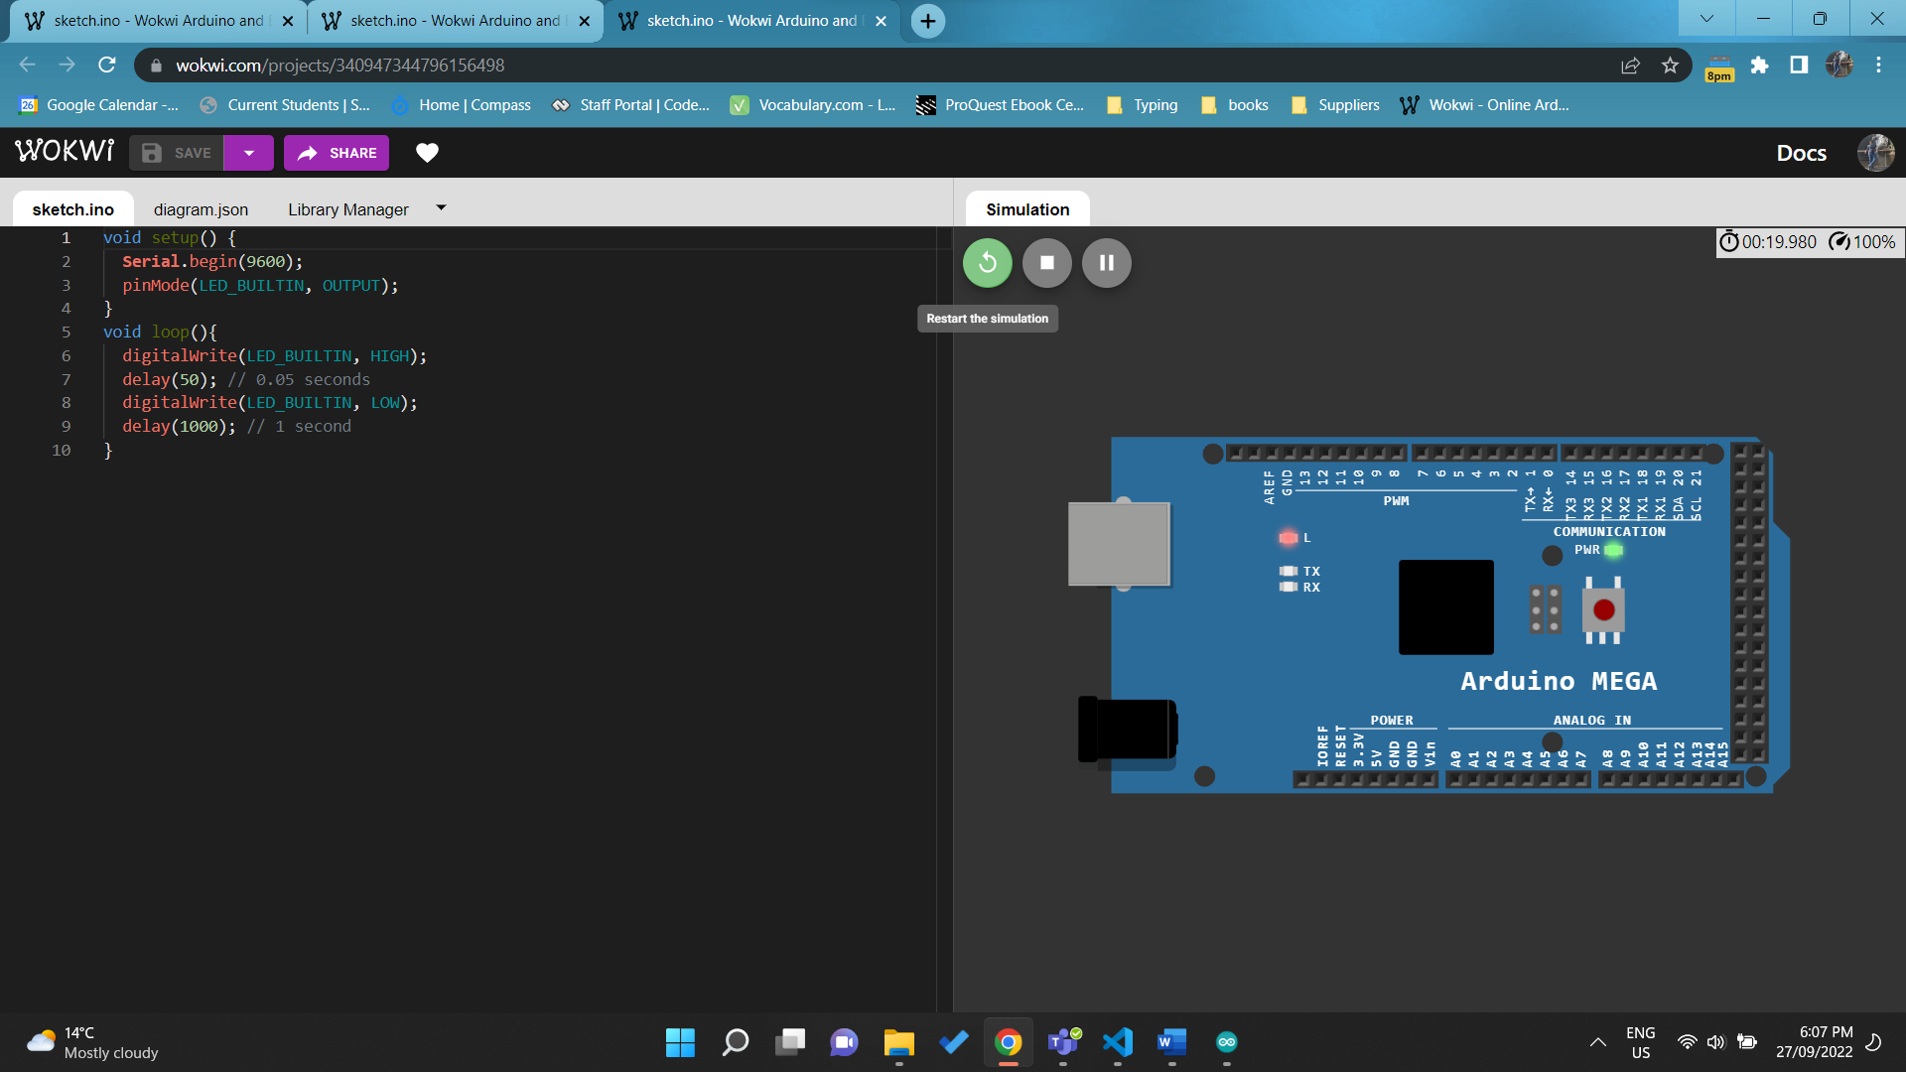

<https://wokwi.com/projects/340947344796156498>

Q6. Write a program that will On the LED for 1 second and off the LED for 2 seconds. Make sure that the LED is connected to pin 7. (Require Demonstration)

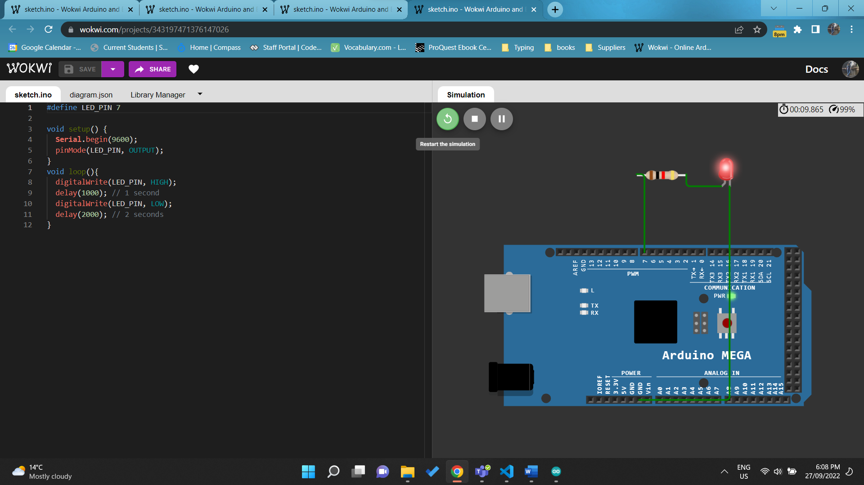 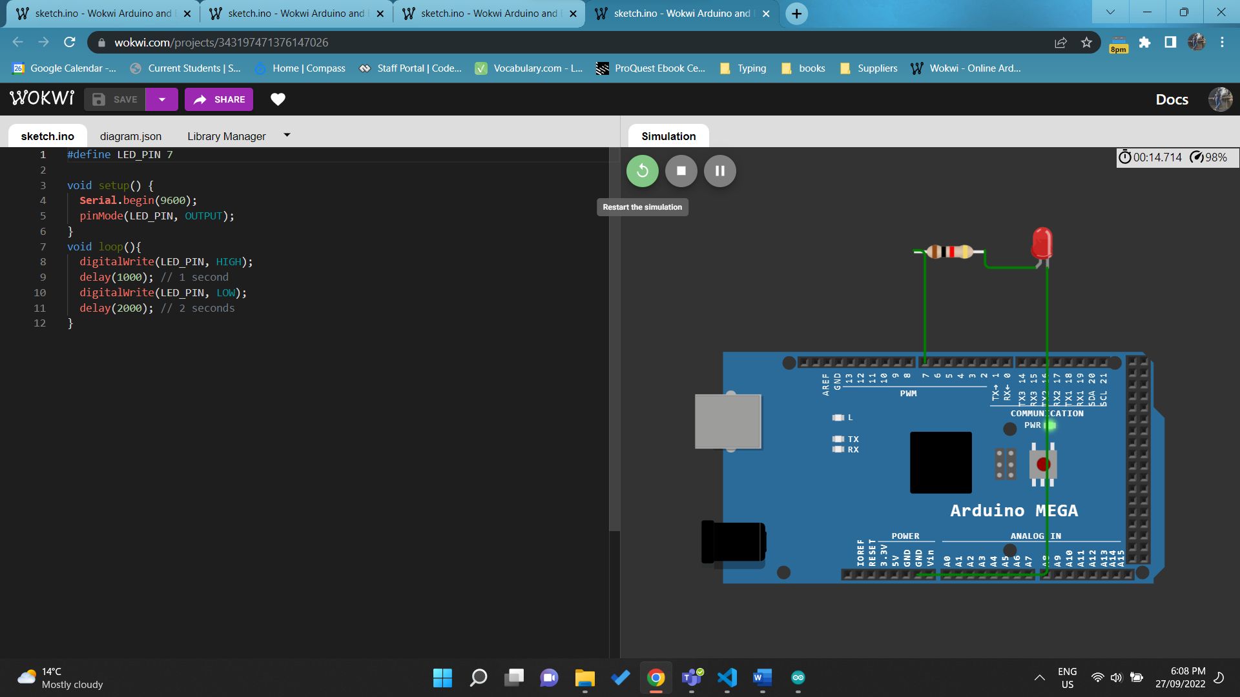

<https://wokwi.com/projects/343197471376147026>

Q7. Briefly explain the **common data types** used in Arduino

void – means nothing.

Boolean – Saves true/false, 1/0.

Byte – store a value between 0 to 255 (inclusive).

Char – a single character such as ‘a’, ‘1’ or ‘)’.

Int – stores a numeric whole number between -32,768 to 32,767. However the range is different of different boards.

Unsigned Int – stores a number whole number between 0 to 65,535.

Float – stores a numeric decimal value between 3.4028235E+38 and -3.4028235E+38.

Q8. Write a simple program to find out the students mark (x) belongs to Higher Distinction, Distinction, Credit, Pass or fail. Add the screenshot for the following marks x= 45,55,60,80 (please use switch statements) (Require Demonstration)

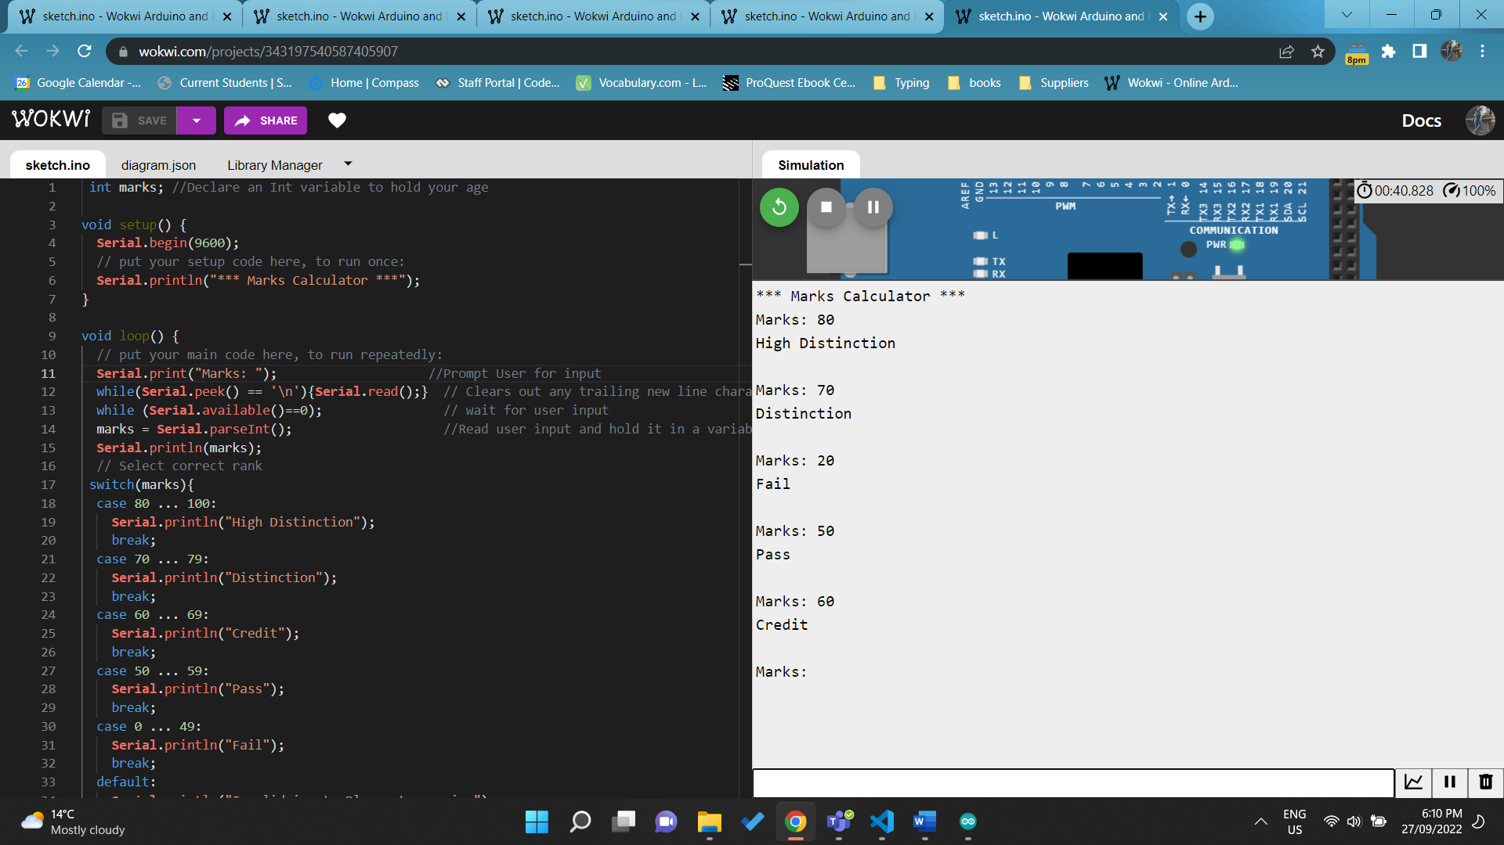

<https://wokwi.com/projects/343197540587405907>

Q9. Write a simple program that will print the values from 1 to 10 in the serial monitor using a while loop. (Require Demonstration)

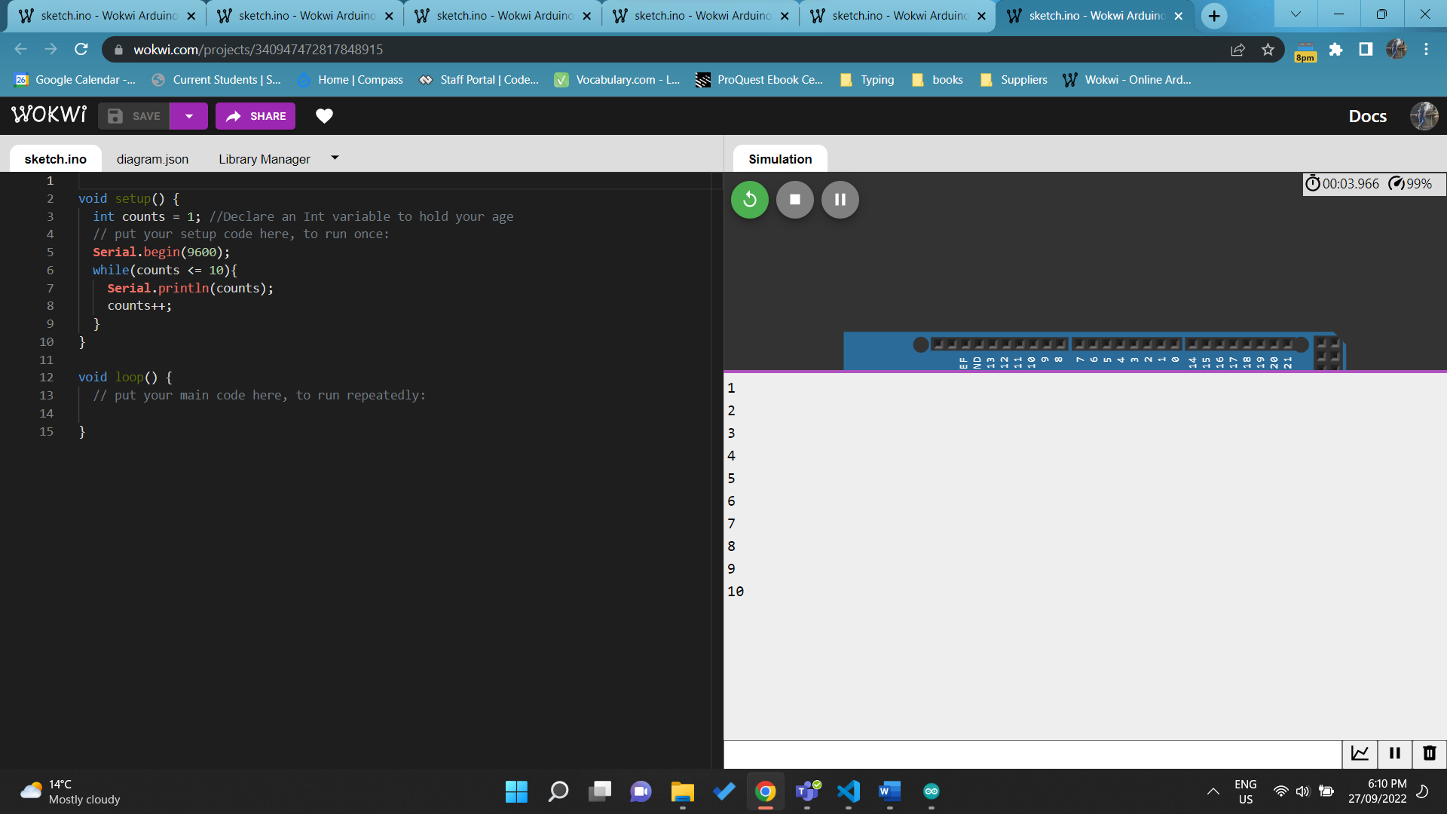

<https://wokwi.com/projects/340947472817848915>

Q10.Write a program that will print your name and the student ID three times in the serial monitor (Use for loop) (Require Demonstration)

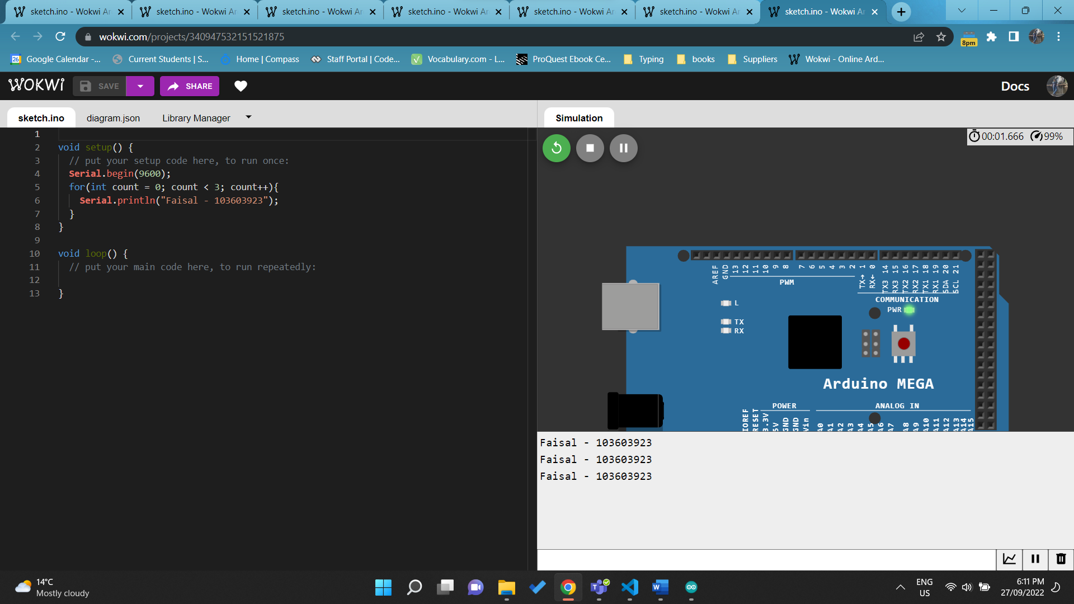

<https://wokwi.com/projects/340947532151521875>

Q11. Write a program that will generate a random number under 300 for ten time and if the generated number is between 0-100 print A, if the generate number is 101-200 print B and if the generated number is 201-300 print C in the serial monitor. (Use if else if statements and for loop) (Require Demonstration)

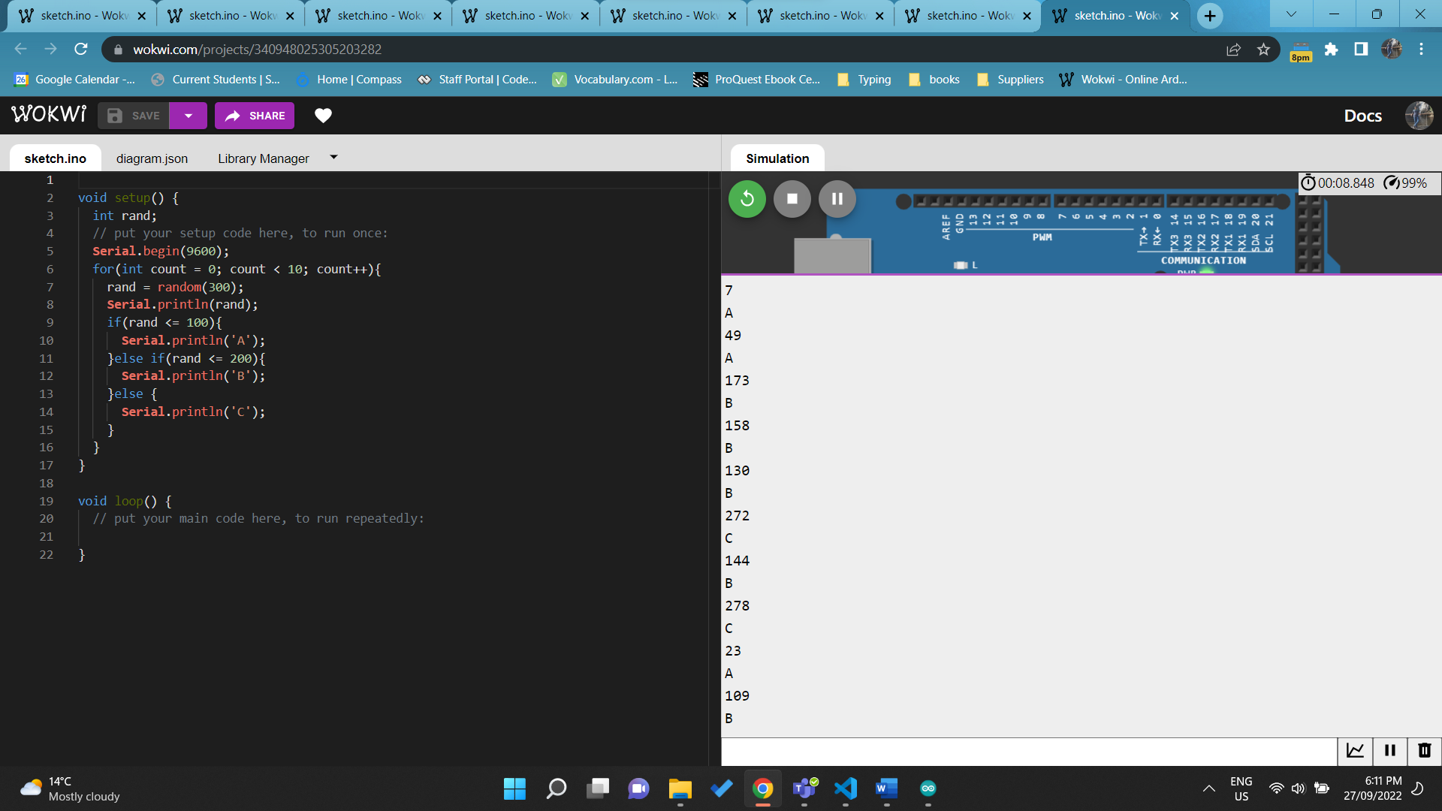

<https://wokwi.com/projects/340948025305203282>

Q12 Write a function to for multiplication, Values needed to multiply be the inputs to the function and function should output the correct value. using the function multiply 16 x 15 and print the correct value in the serial monitor. (Require Demonstration)

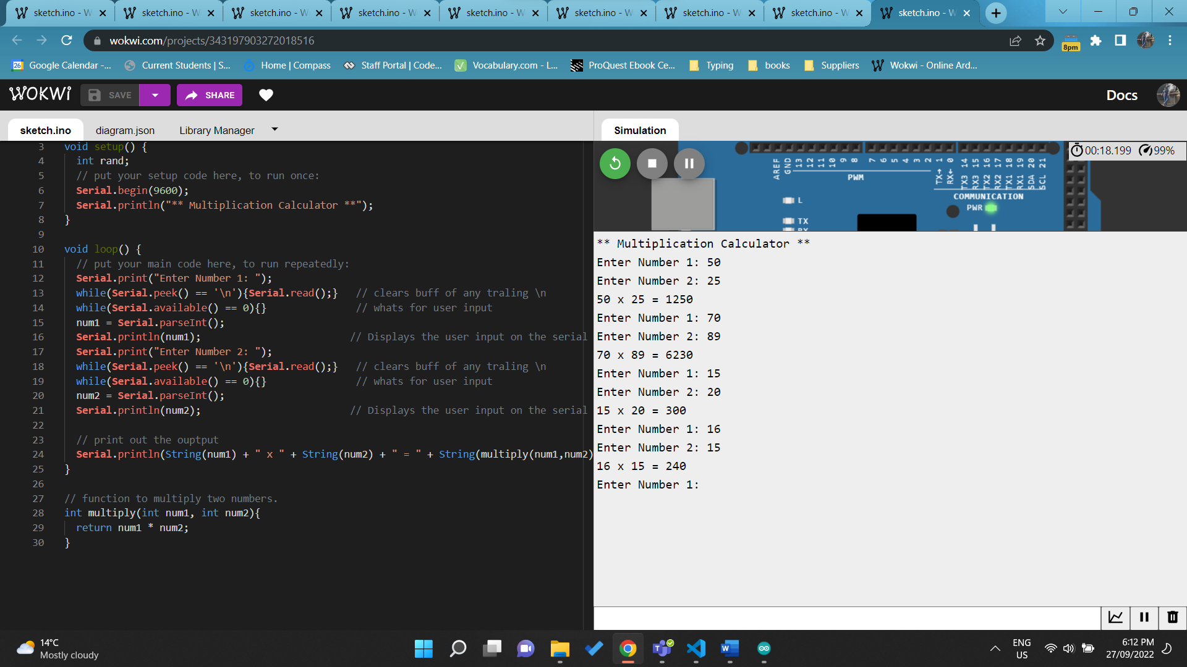

<https://wokwi.com/projects/343197903272018516>

# Pass Borderline Task 2

Q1. Connect the Arduino, write a program that will display your name and the ID number once in the serial monitor.

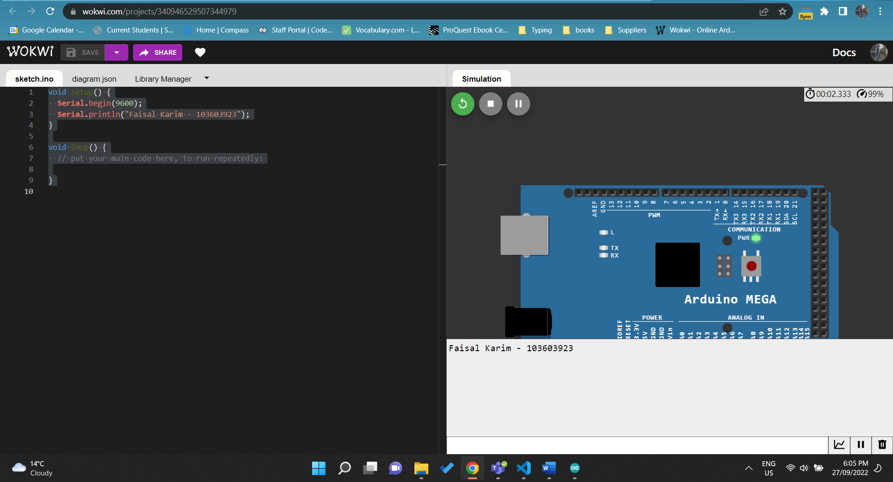

void setup() {

**Serial**.begin(9600);

**Serial**.println("Faisal Karim - 103603923");

}

void loop() {

  // put your main code here, to run repeatedly:

}

<https://wokwi.com/projects/340946529507344979>

Q2. Connect 2 LEDs (remember to use 270 Ohm resistors). Write code to flash LED1 every 1 second and LED2 every 2 seconds. Flashing LED duration is 50 ms.

#define LED_1_PIN 13

#define LED_2_PIN 12

void setup() {

  pinMode(LED_1_PIN, OUTPUT);

  pinMode(LED_2_PIN, OUTPUT);

}

void loop() {

  // put your main code here, to run repeatedly:

  digitalWrite(LED_1_PIN, HIGH);

  delay(50);

  digitalWrite(LED_1_PIN, LOW);

  delay(1000);

  digitalWrite(LED_1_PIN, HIGH);

  digitalWrite(LED_2_PIN, HIGH);

  delay(50);

  digitalWrite(LED_1_PIN, LOW);

  digitalWrite(LED_2_PIN, LOW);

  delay(1000);

}

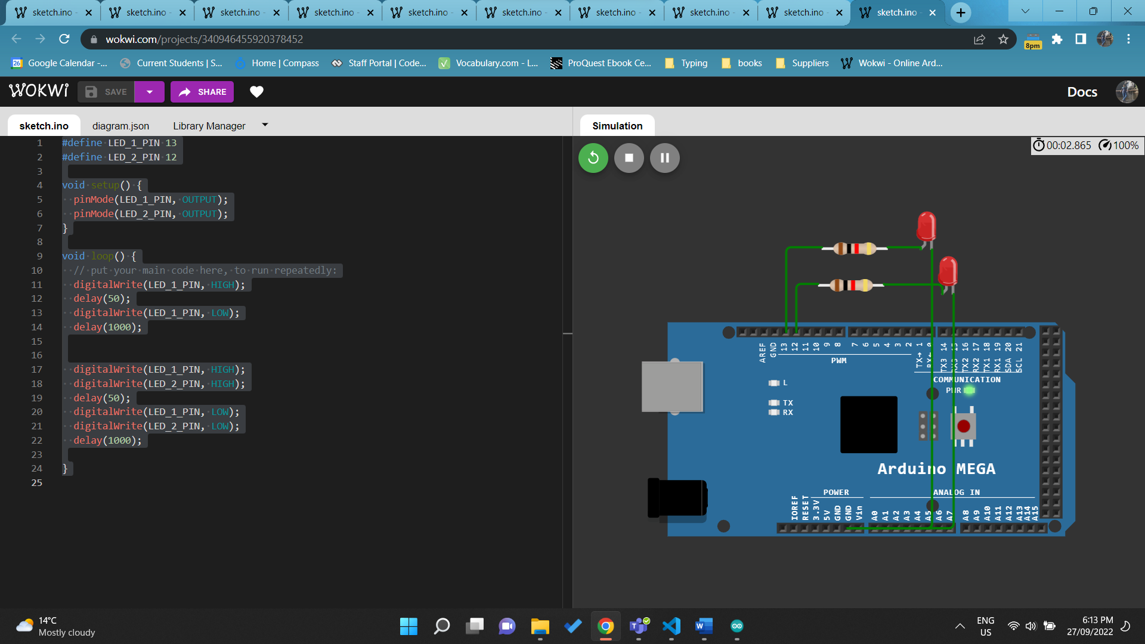

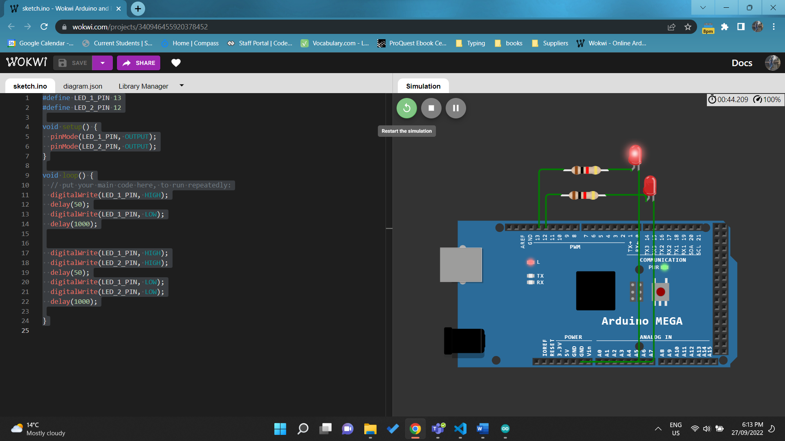

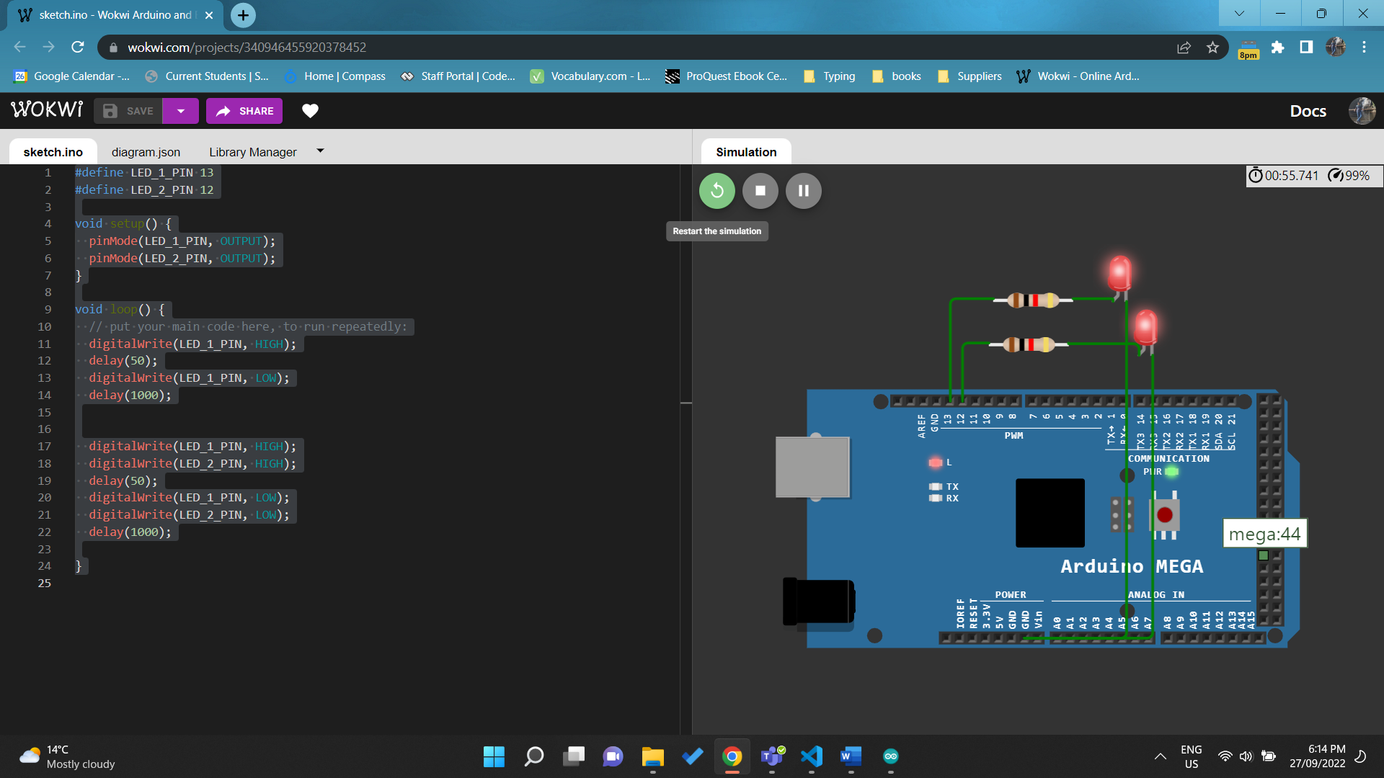

<https://wokwi.com/projects/340946455920378452>

Q3. Connect 5 LEDs (remember to use 270 Ohm resistors). Write code to take input (a single number ranging from 1 to 5) from Serial monitor and light up the corresponding LED. Only one LED lit up at a time. (Require Demonstration)

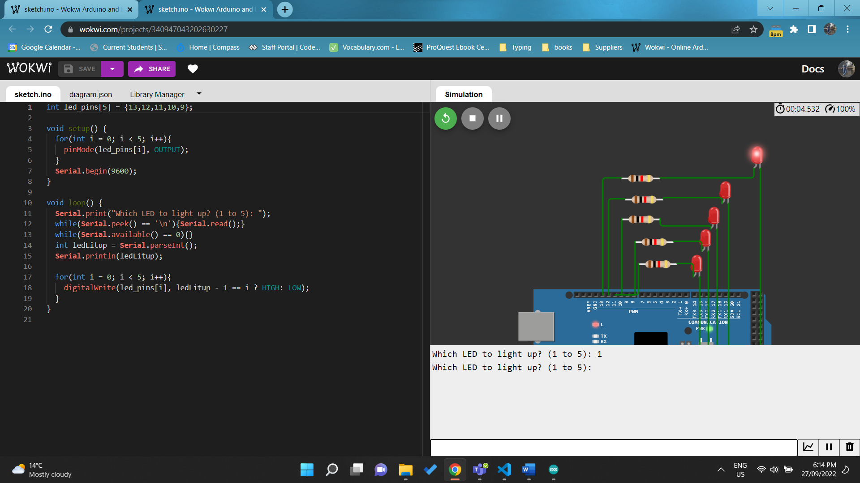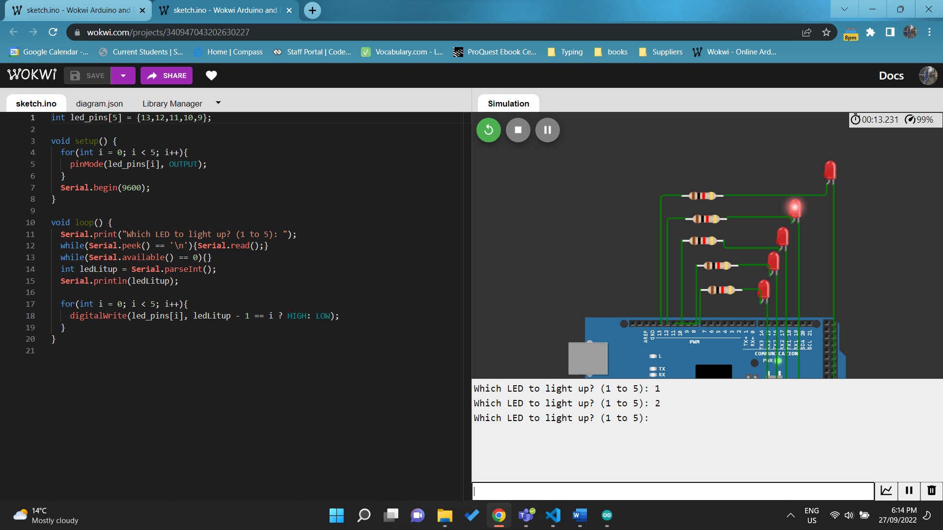 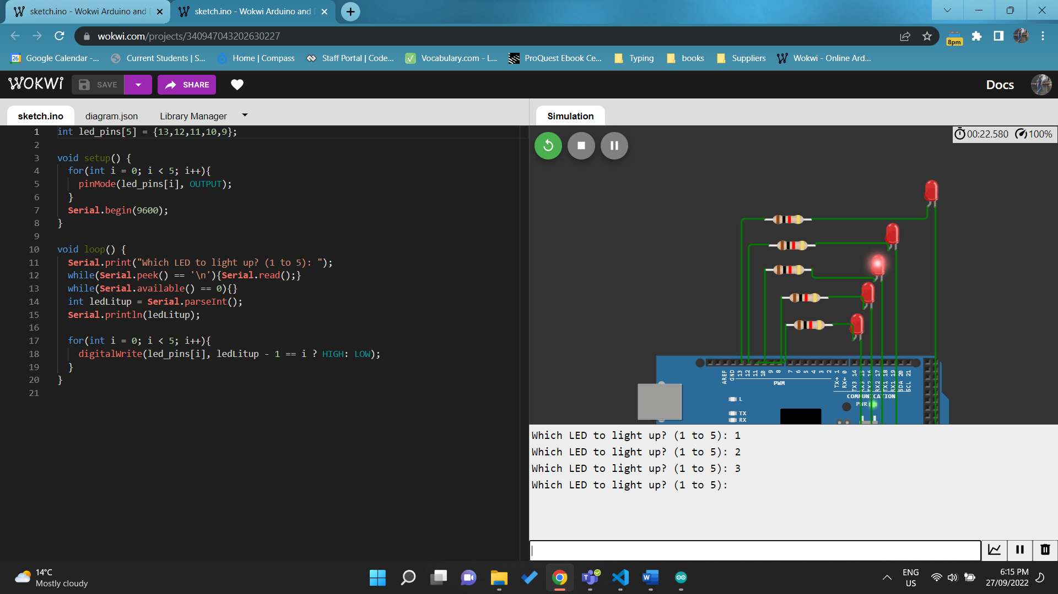 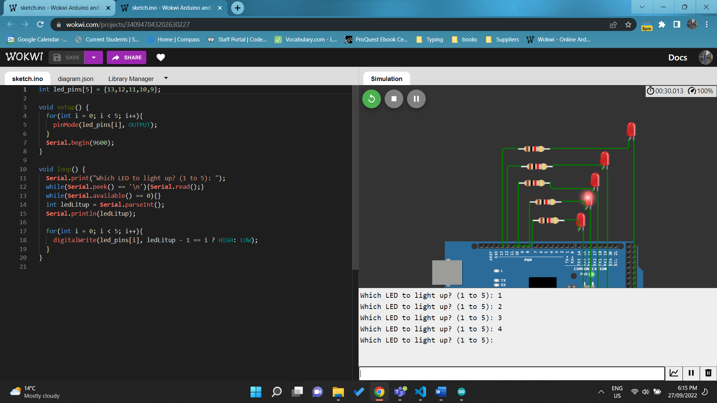 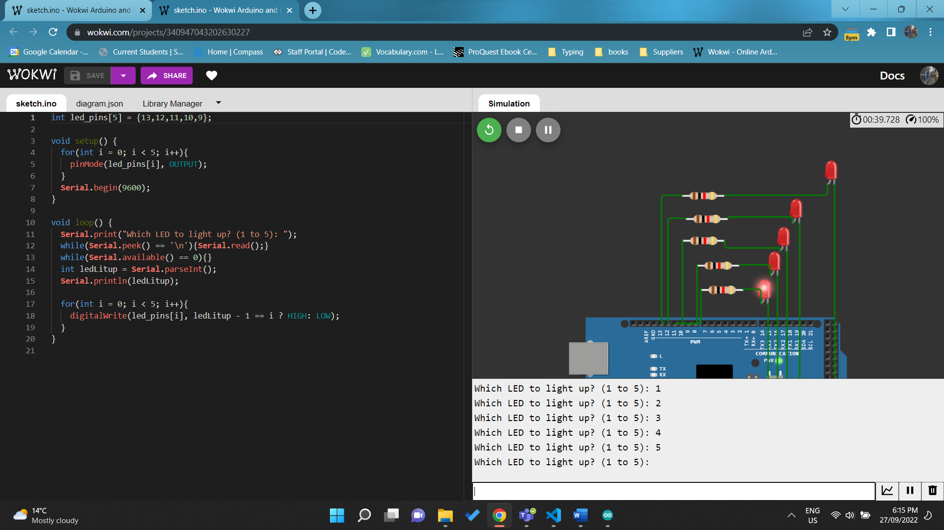

<https://wokwi.com/projects/340947043202630227>

Q4. Write code to toggle the LED when the button is pressed. (Require Demonstration)

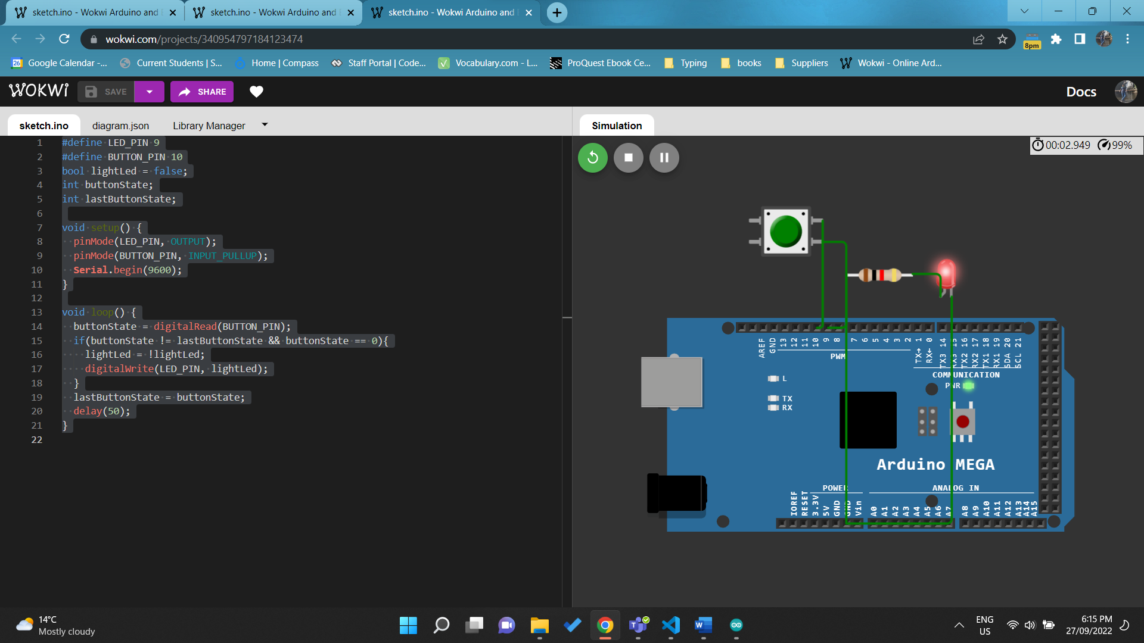

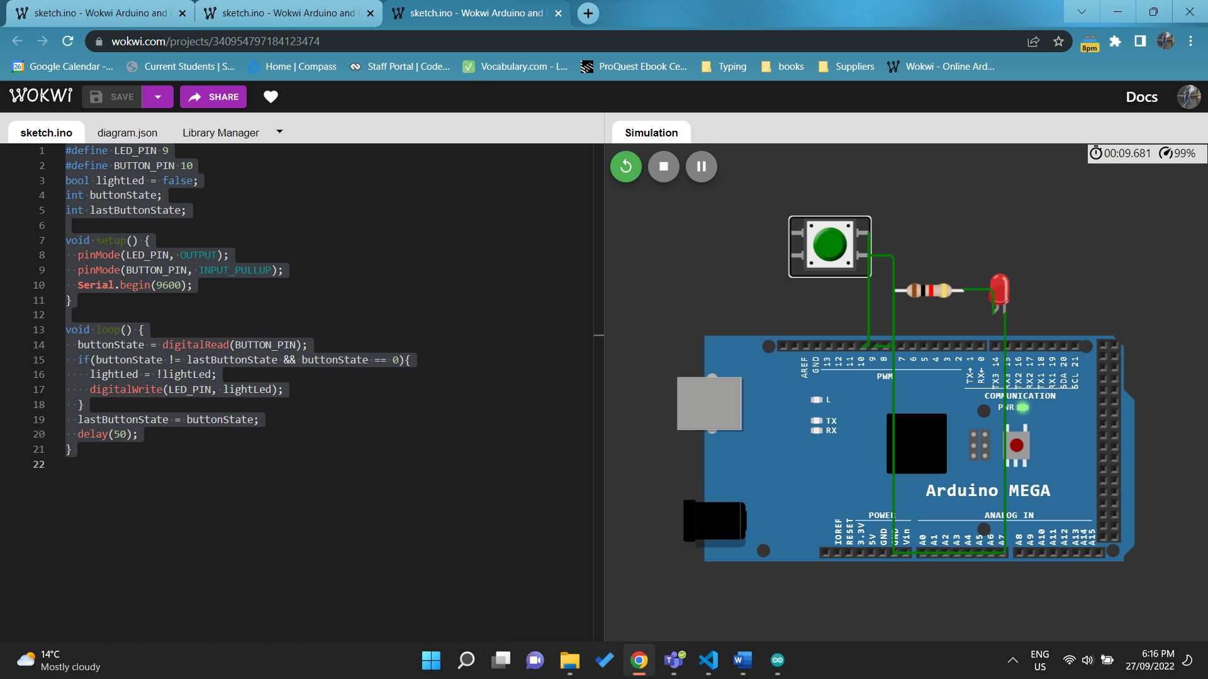

<https://wokwi.com/projects/343942283332158036>

Q5. Write code to dim the LED until off and then glow the LED to fully bright (Use PWM).

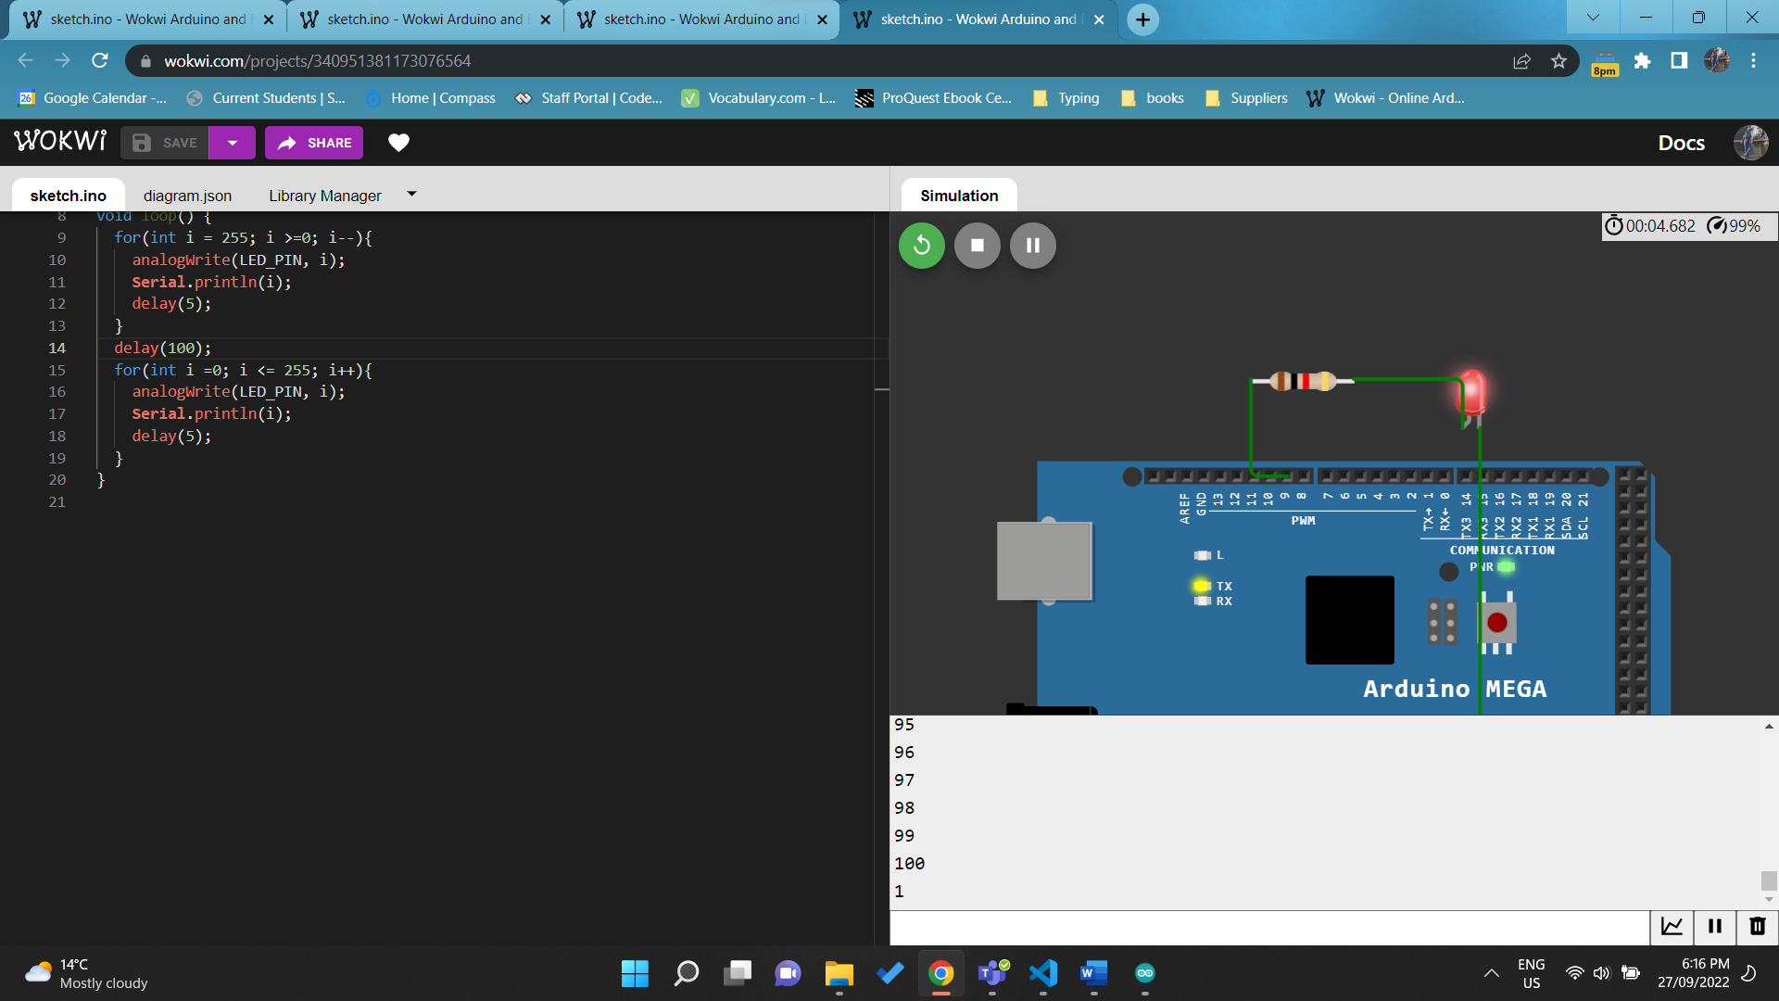

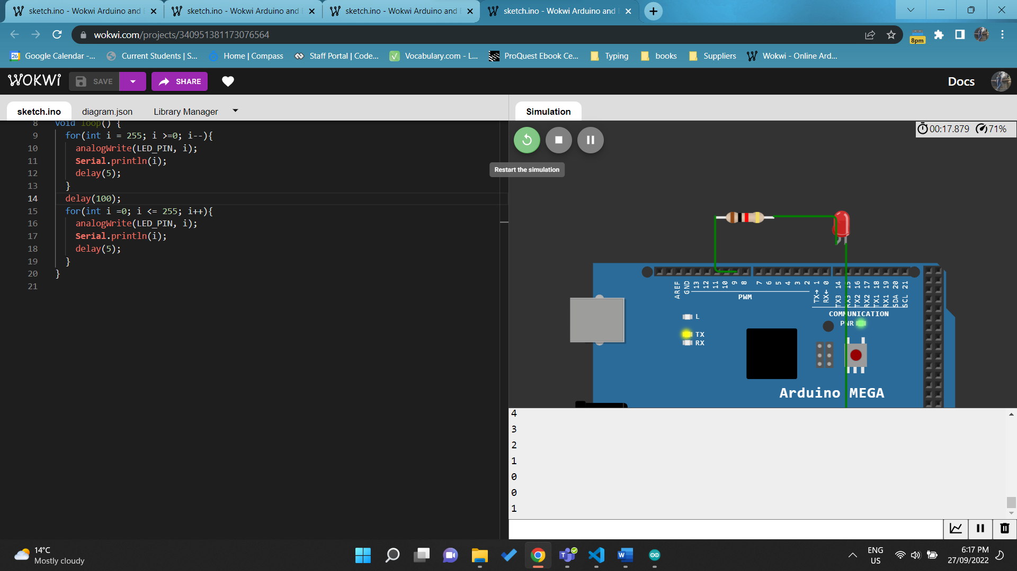

#define LED_PIN 9

void setup() {

  pinMode(LED_PIN, OUTPUT);

**Serial**.begin(9600);

}

void loop() {

  for(int i = 255; i >=0; i--){

    analogWrite(LED_PIN, i);

**Serial**.println(i);

    delay(5);

  }

  delay(100);

  for(int i =0; i <= 255; i++){

    analogWrite(LED_PIN, i);

**Serial**.println(i);

    delay(5);

  }

}

<https://wokwi.com/projects/340951381173076564>

Q6. Write code to change the volume of the piezo buzzer based on input from Serial monitor (Use PWM). (Require Demonstration)

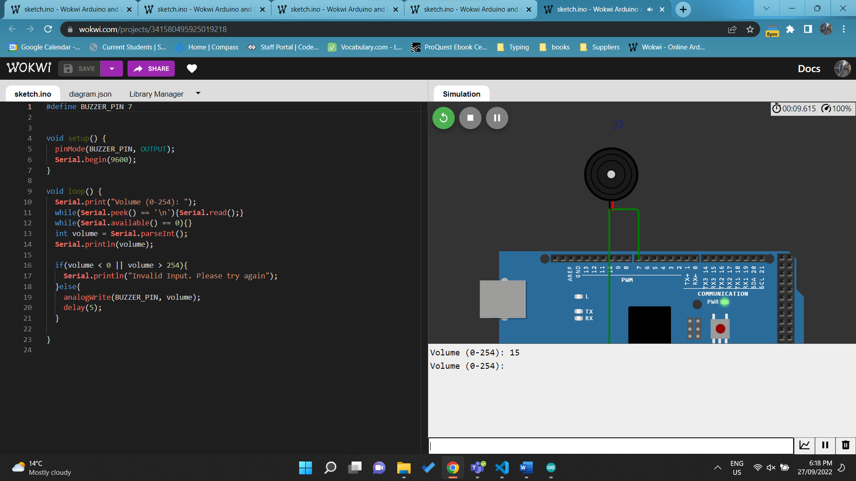

<https://wokwi.com/projects/341580495925019218>

Q7. Connect the seven segment LED display, write code to display number from 9 to 0 (change every 1 second). (Require Demonstration)

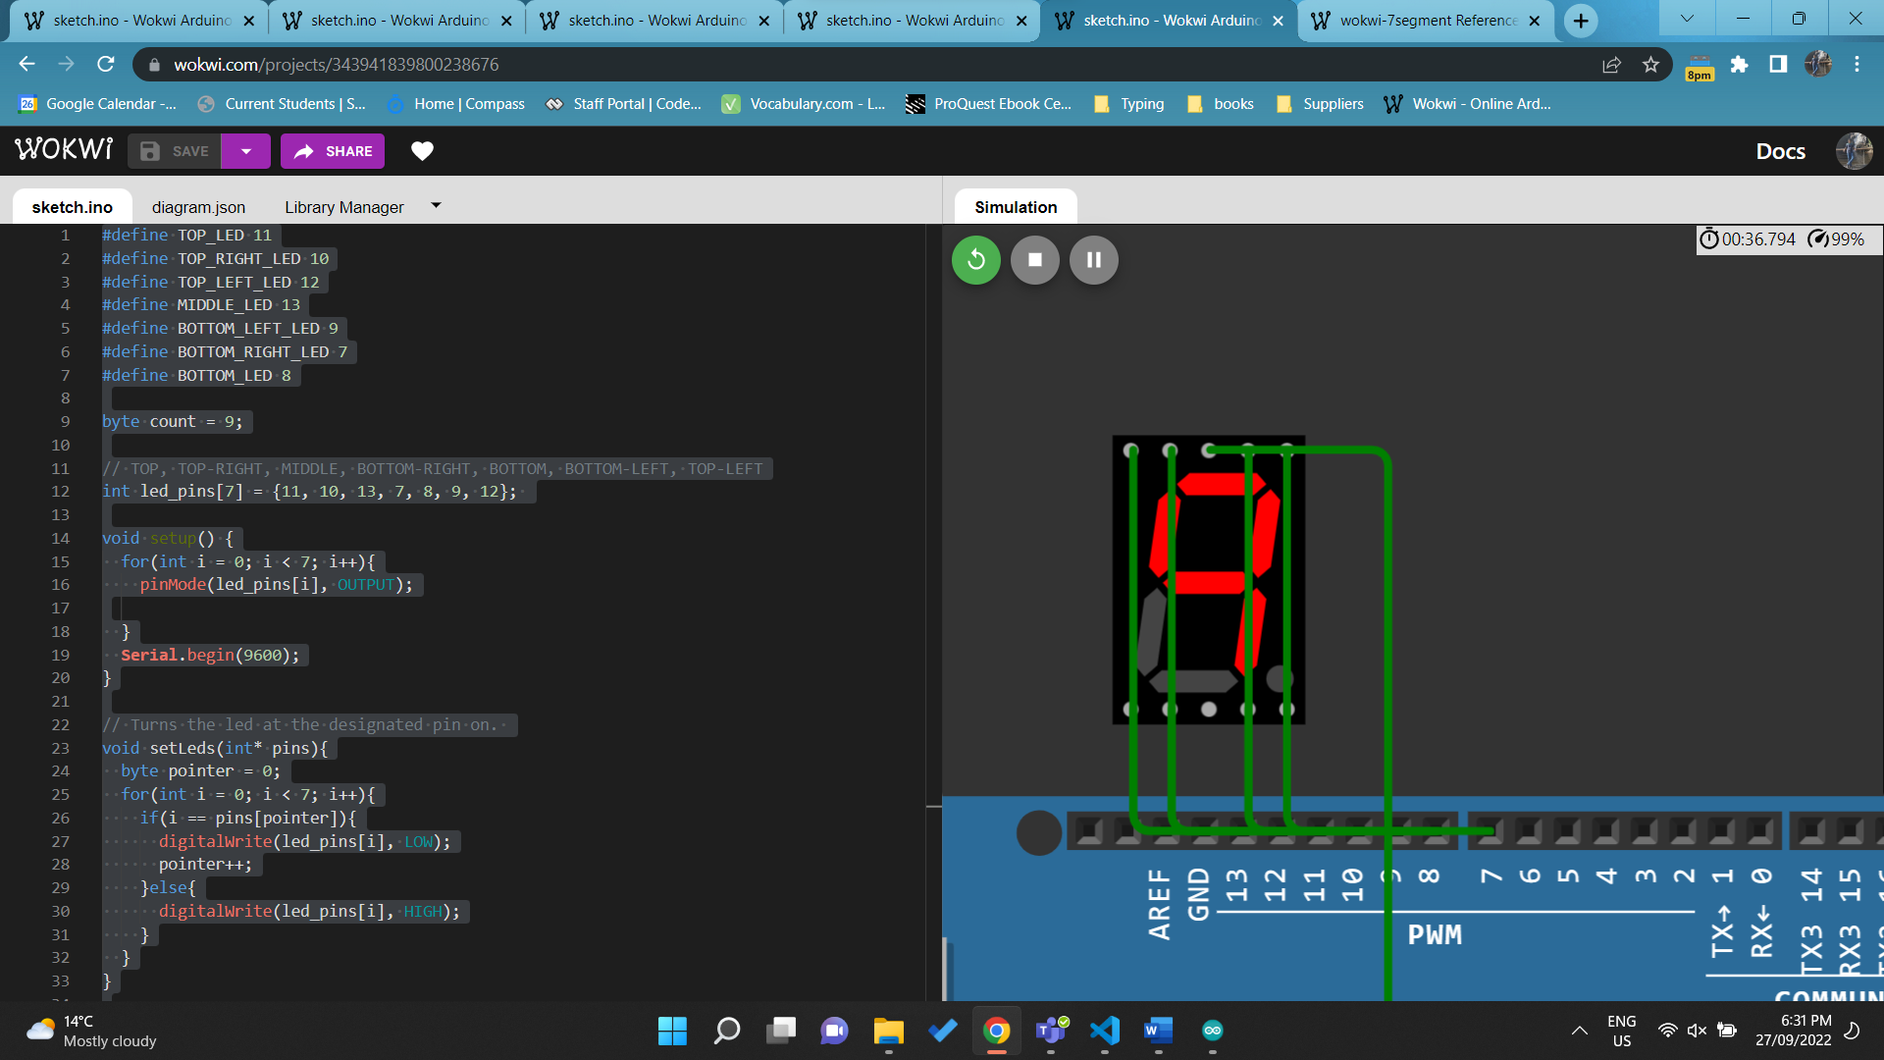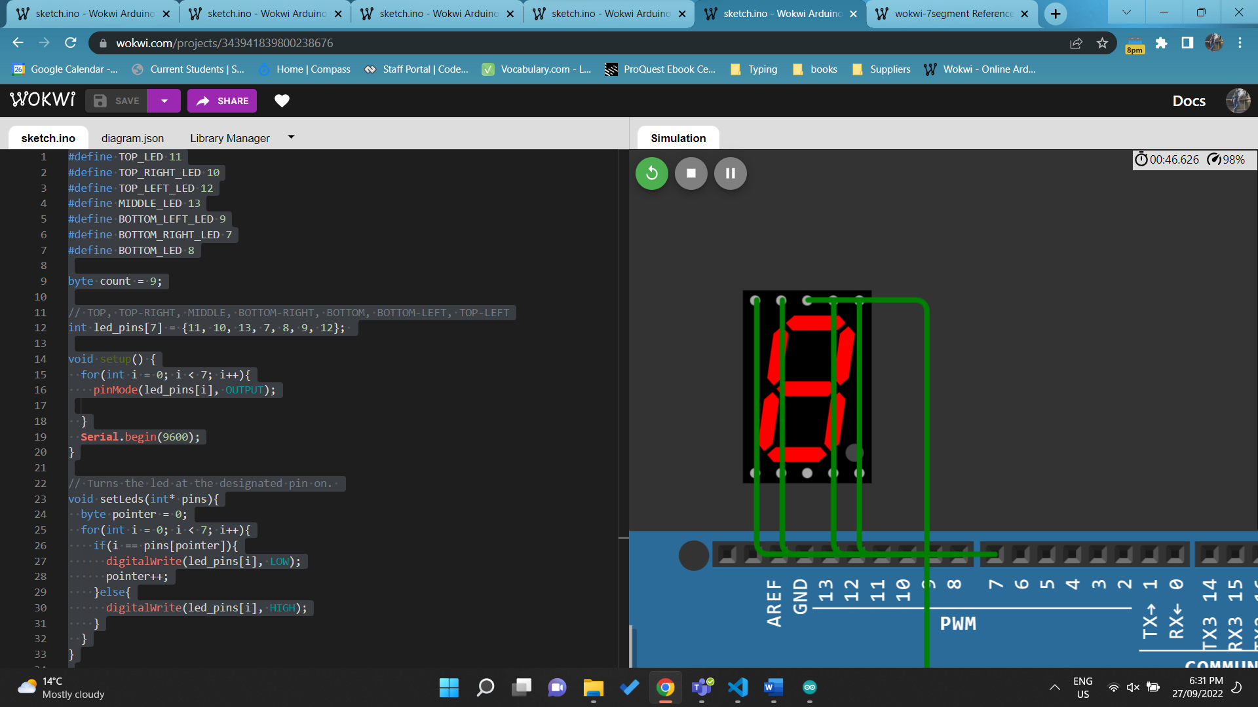 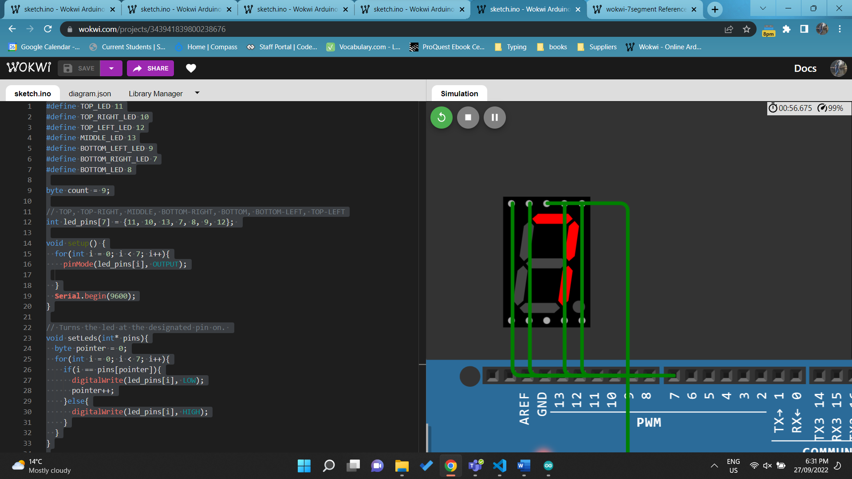 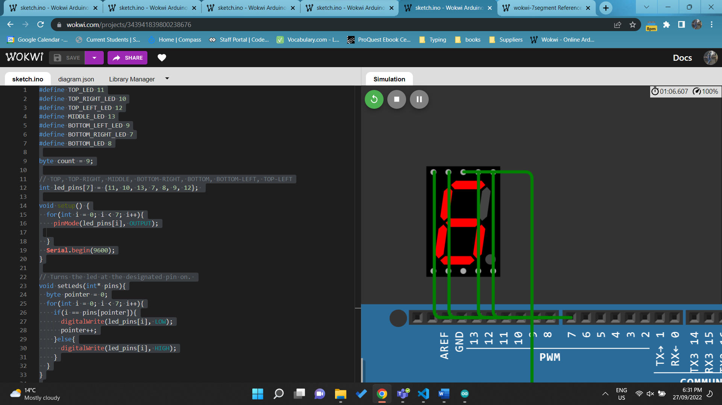 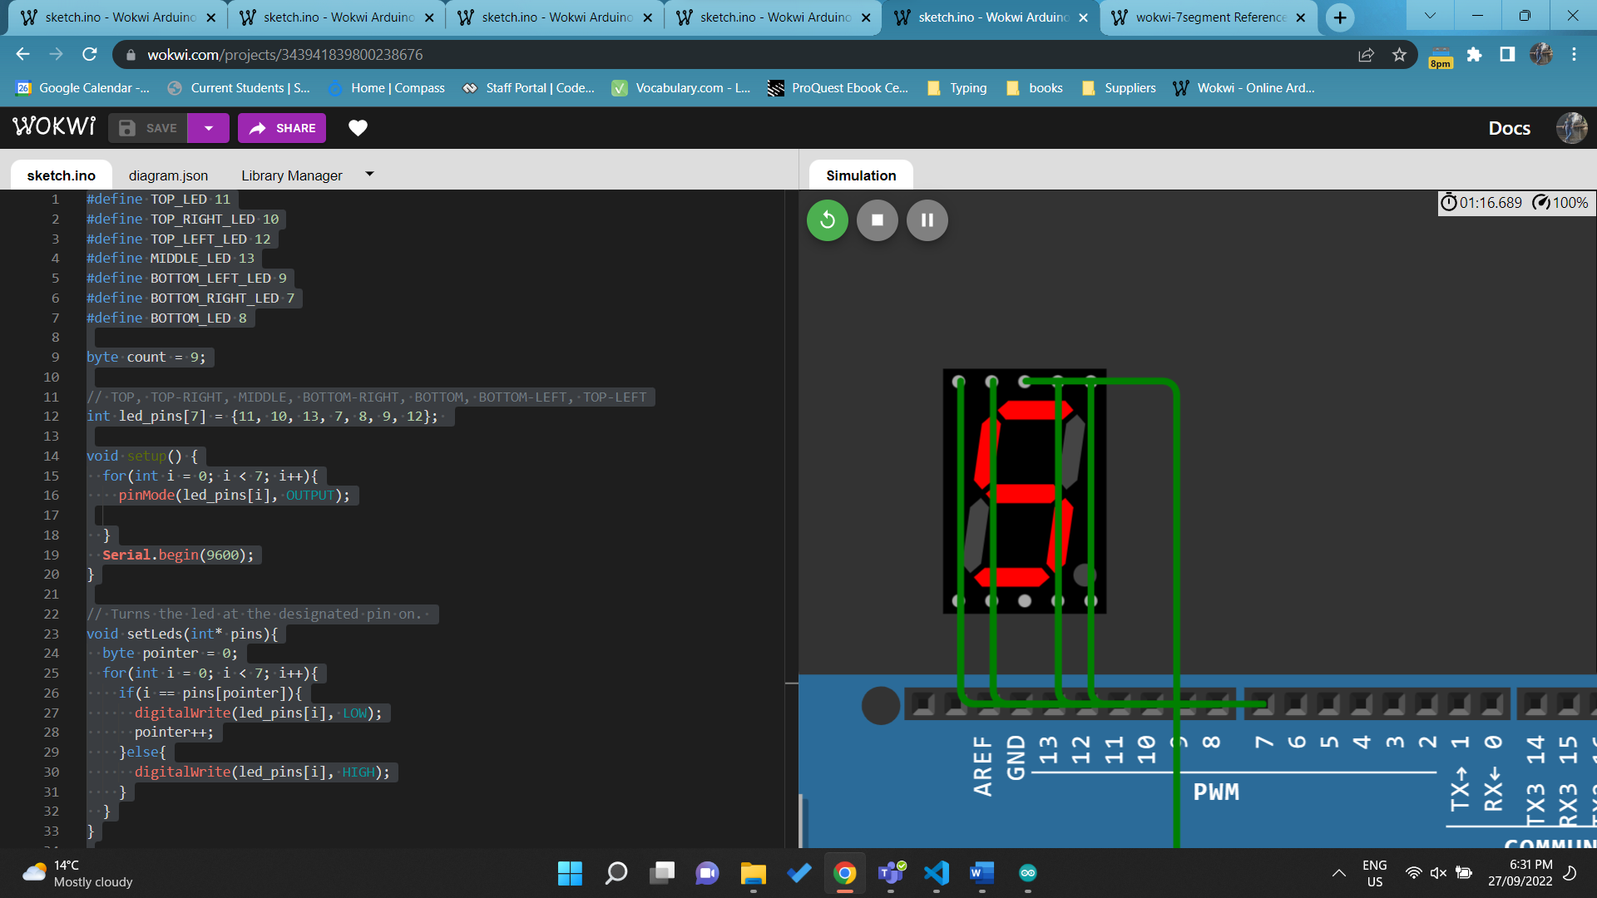 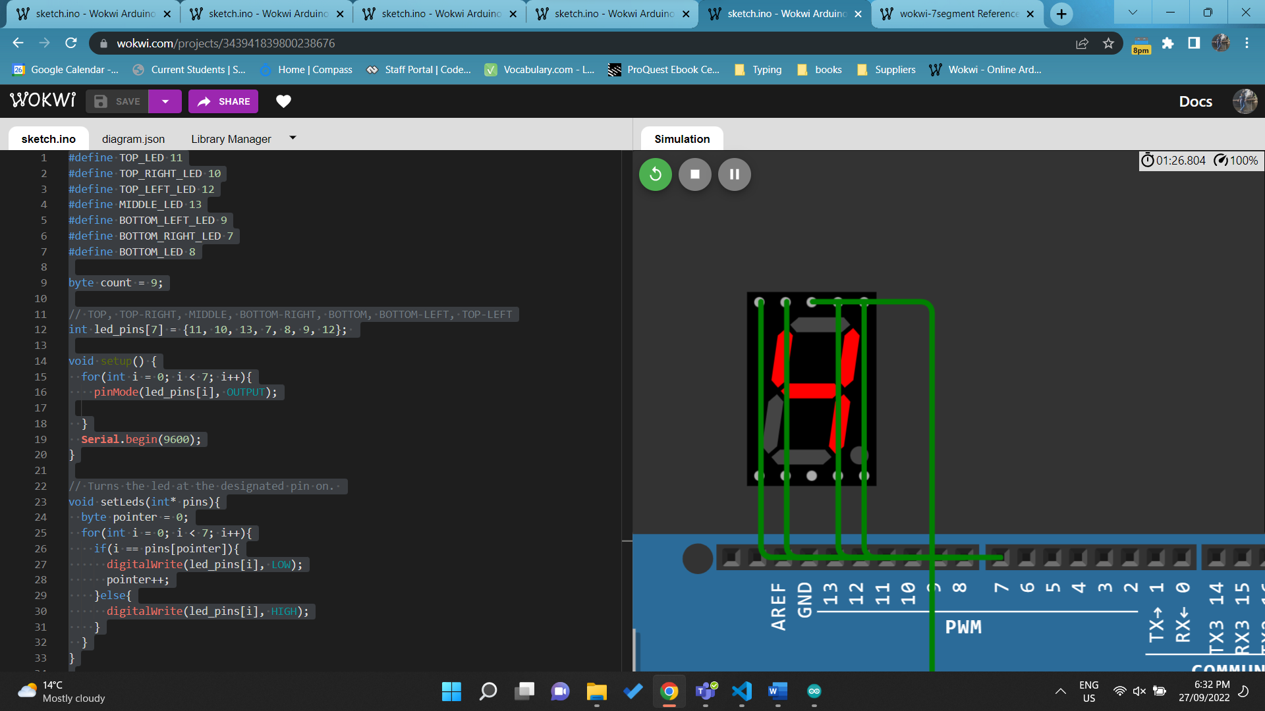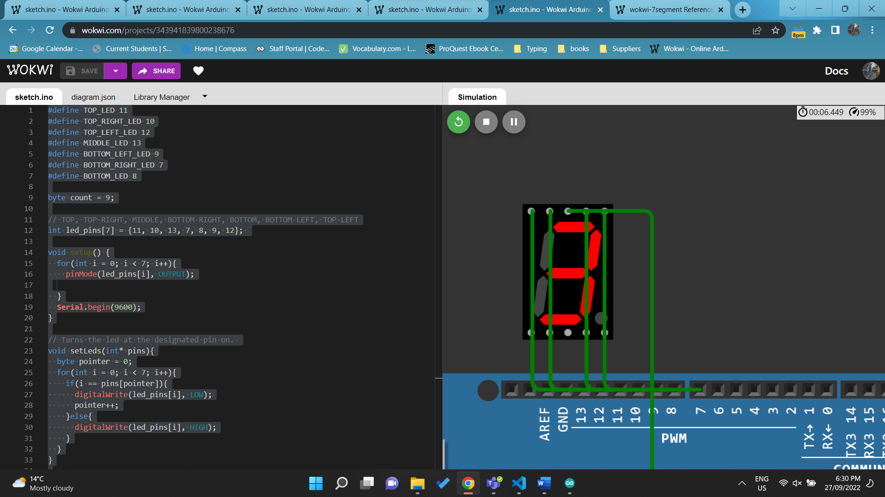 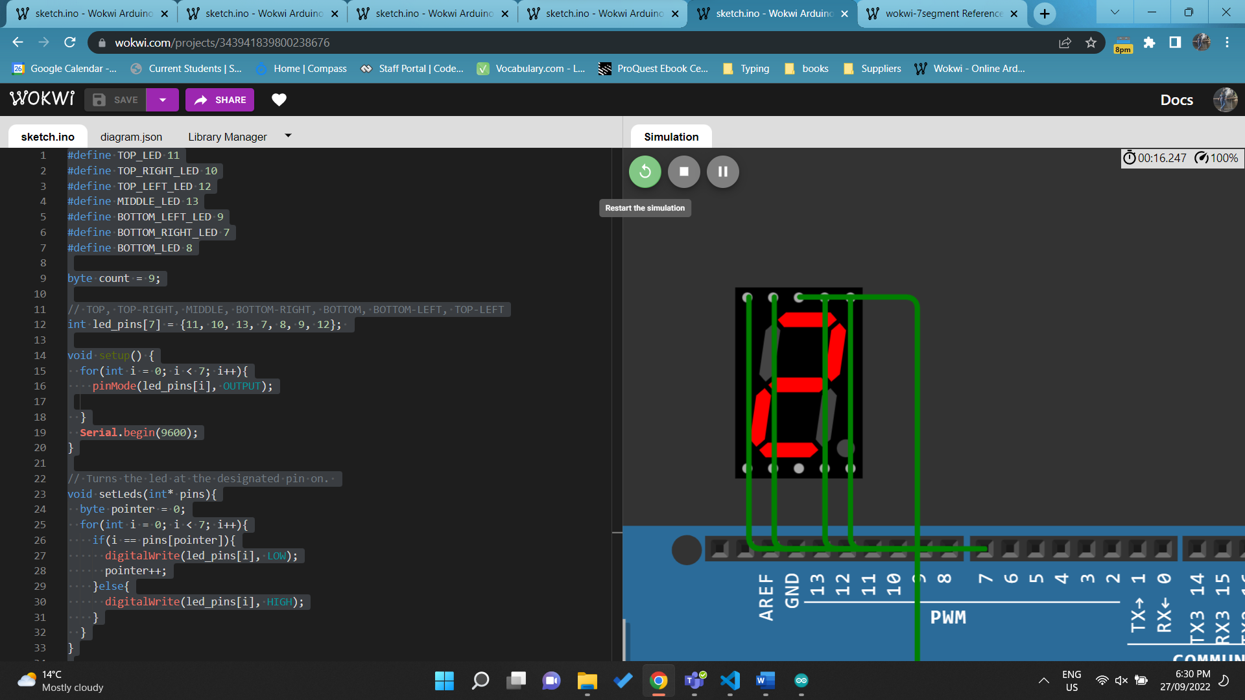 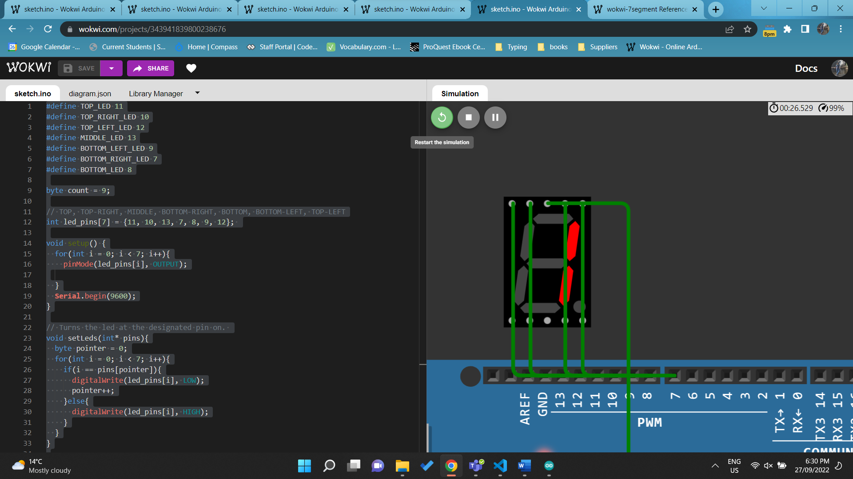

<https://wokwi.com/projects/343941839800238676>

# Pass Borderline Task 3&4

Q1. Connect OLED display to Arduino Mega. Write code to draw Olympic Rings symbol at centre of the OLED display. (require demonstration)

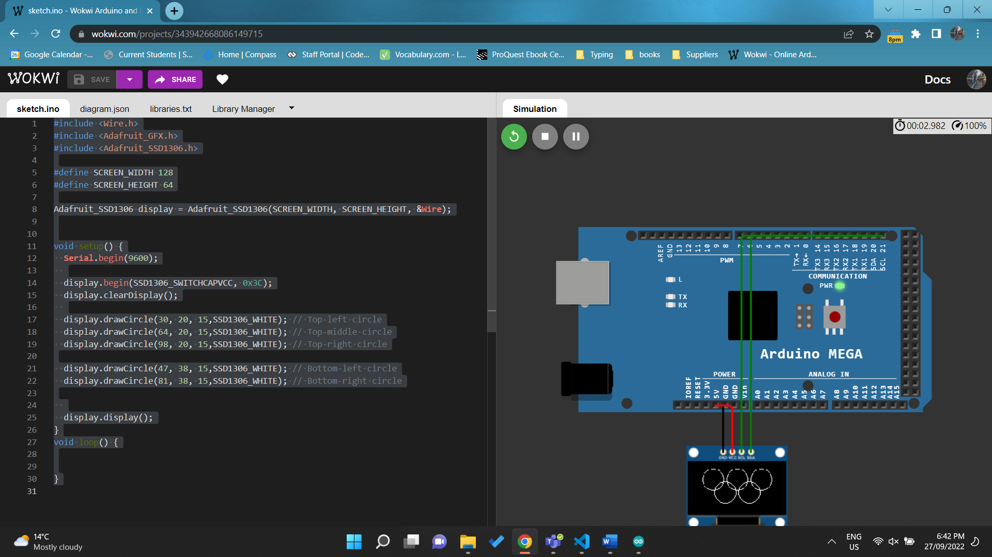

<https://wokwi.com/projects/343942668086149715>

Q2. Connect OLED display and HC-SR04 Ultrasonic Distance Sensor to Arduino Mega. Write a code to present the distance value from Ultrasonic sensor as a rectangle (height of the rectangle will be the same while the width of the rectangle will be changed based on the distance value). Display a certain simple text on OLED display based on the distance value: “Safe” when the distance >= 200, “Careful” when 80 <= distance < 200 and “Too Closed” when distance < 80. (require demonstration)

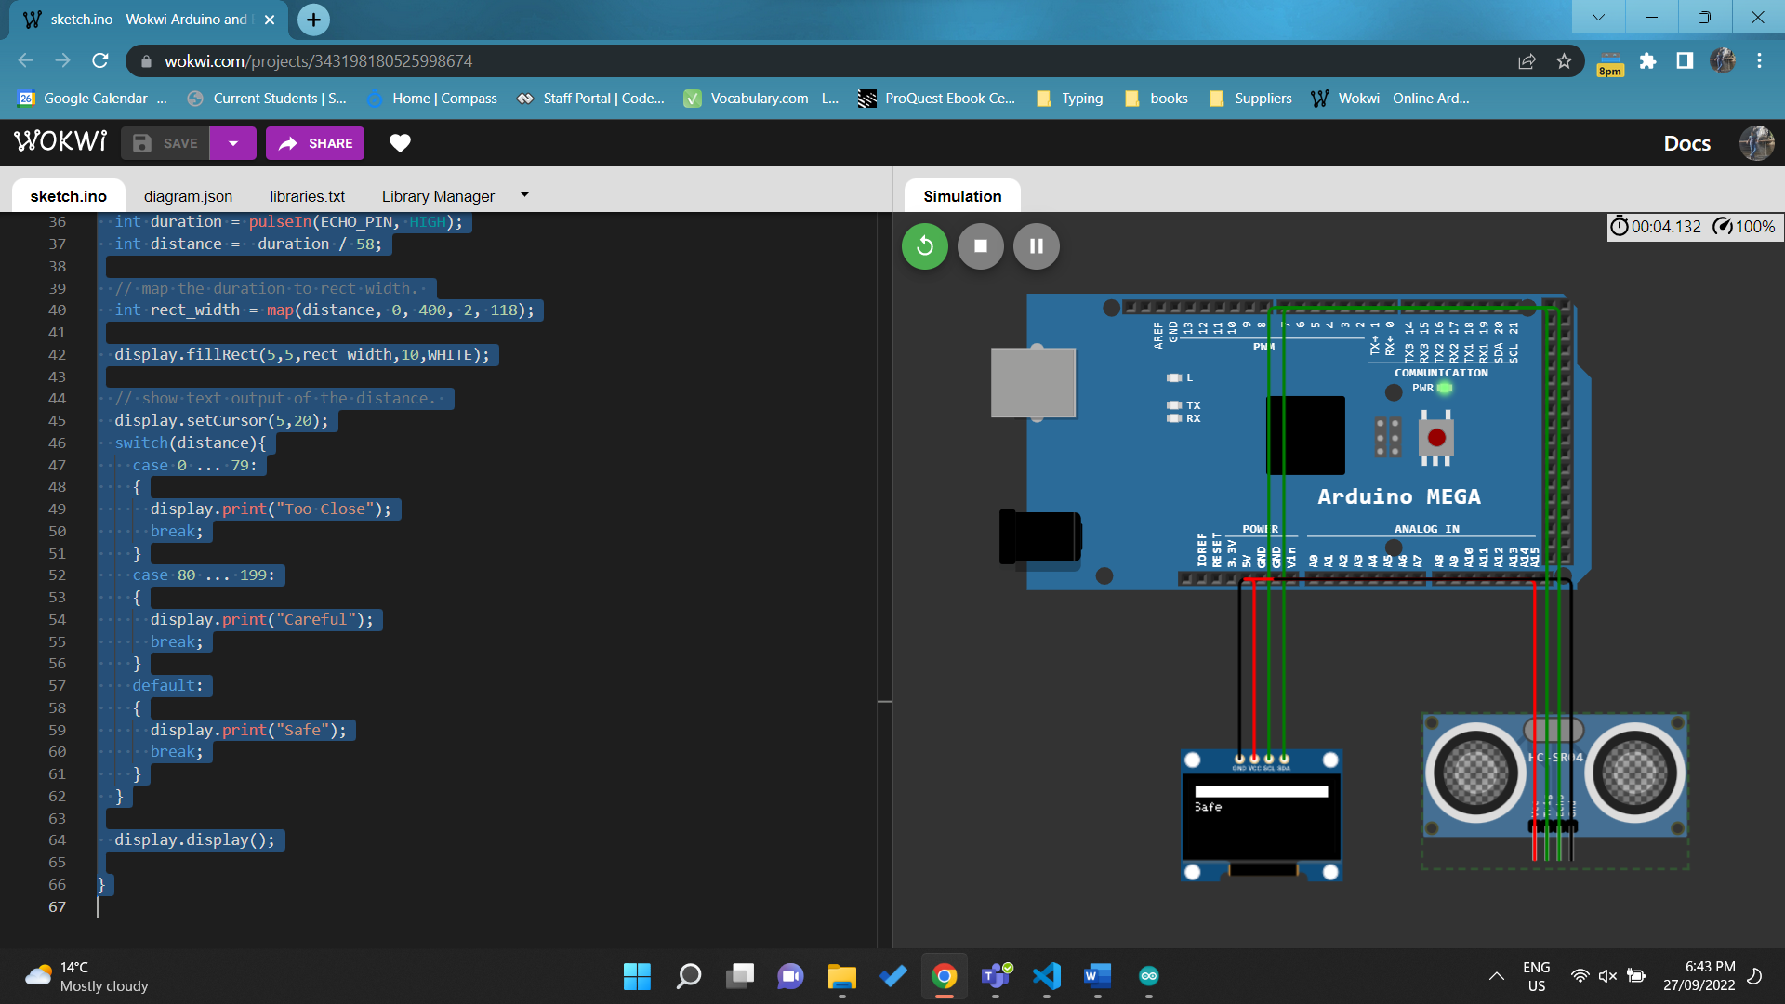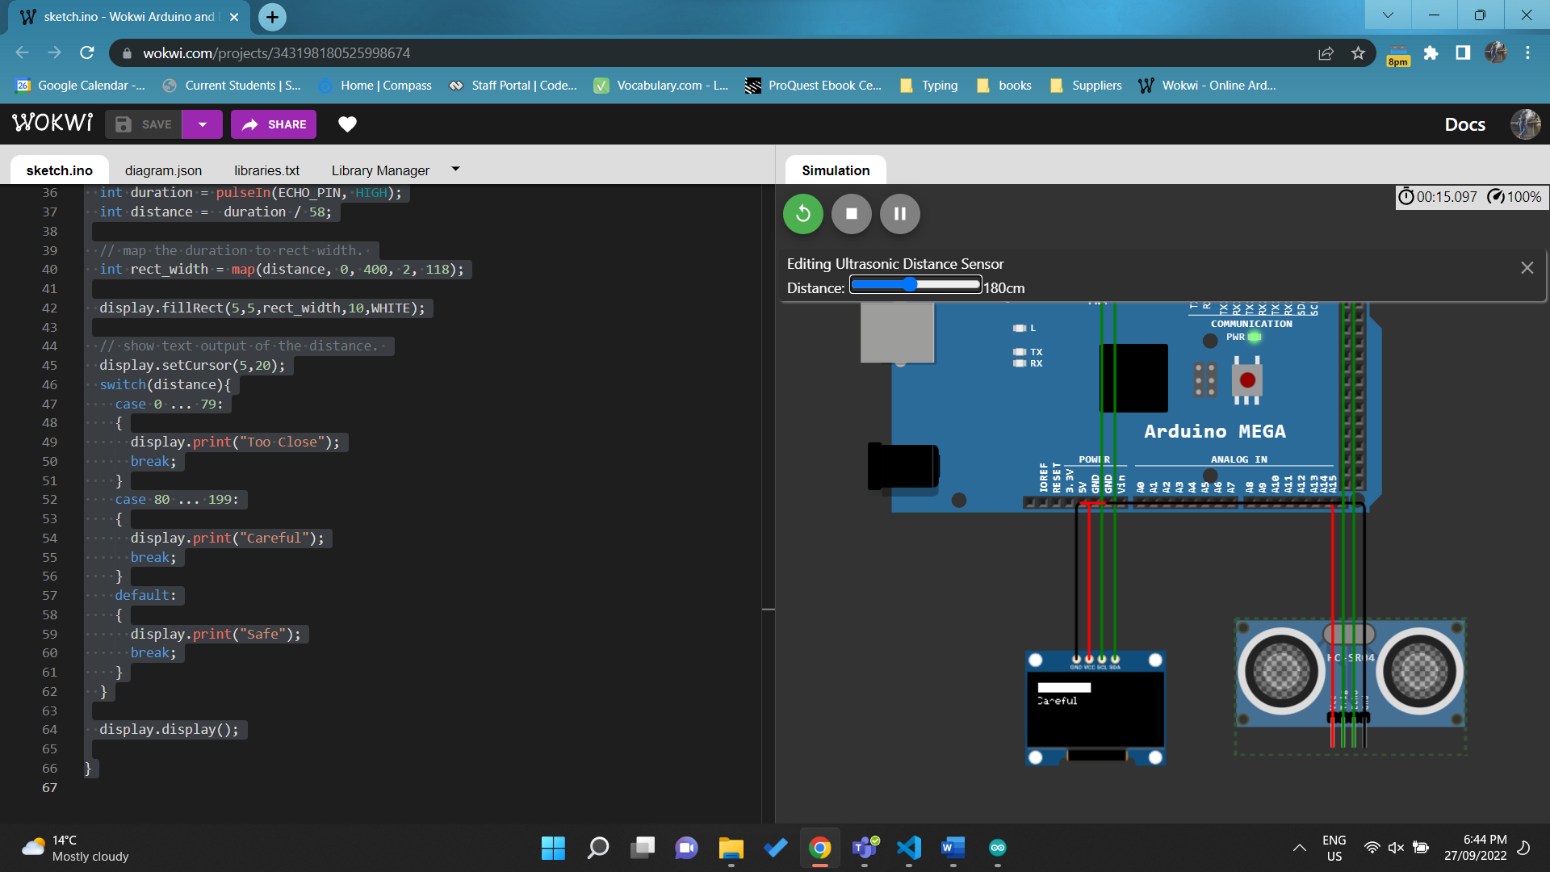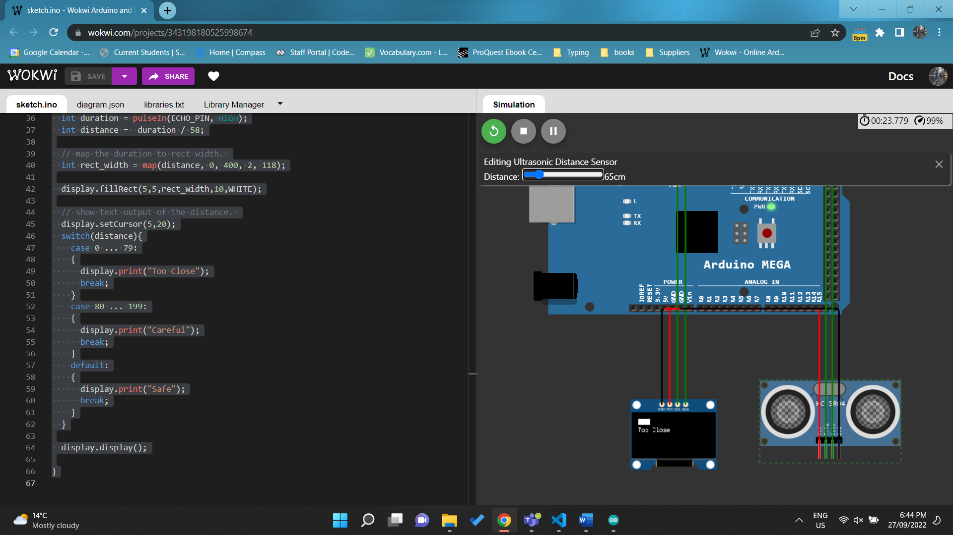

<https://wokwi.com/projects/343198180525998674>

Q3. Connect DS1307 RTC and LED Matrix with “chain” attribute is 5 to Arduino Mega. Write a code to display the current time from DS1307 RTC to LED Matrix with the speed value is 10, pause value is 100, and text alignment is PA_CENTER. (require demonstration)

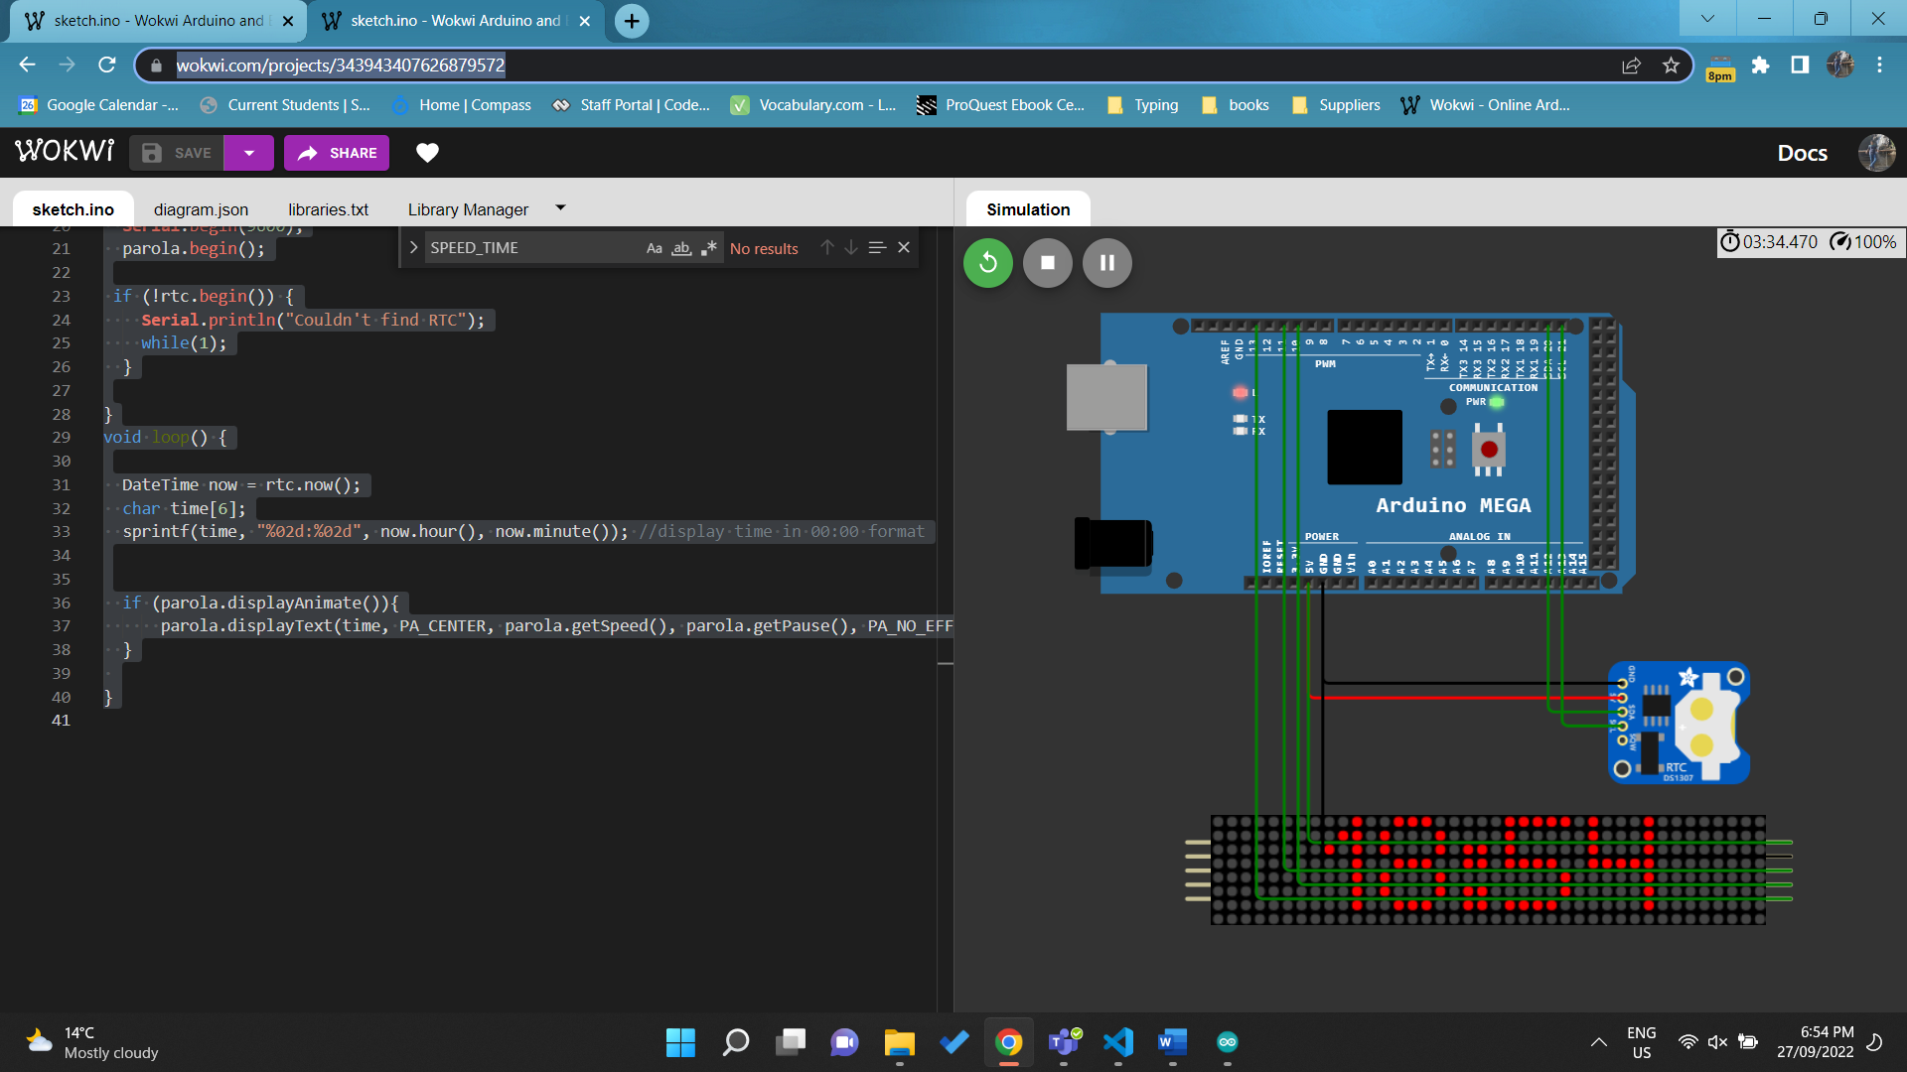

<https://wokwi.com/projects/343943407626879572>

# Pass Borderline Task 5

Q1. Write a program that displays the correct reading of the temperature in the immediate surrounding of the temperature sensor in Celsius and Fahrenheit using appropriate calibration steps on the serial monitor. (Require demonstration)

<https://wokwi.com/projects/341394269421961812>

Q2. Write a program that displays the correct voltage reading from the potentiometer as you dial it on the serial monitor. (Require demonstration)

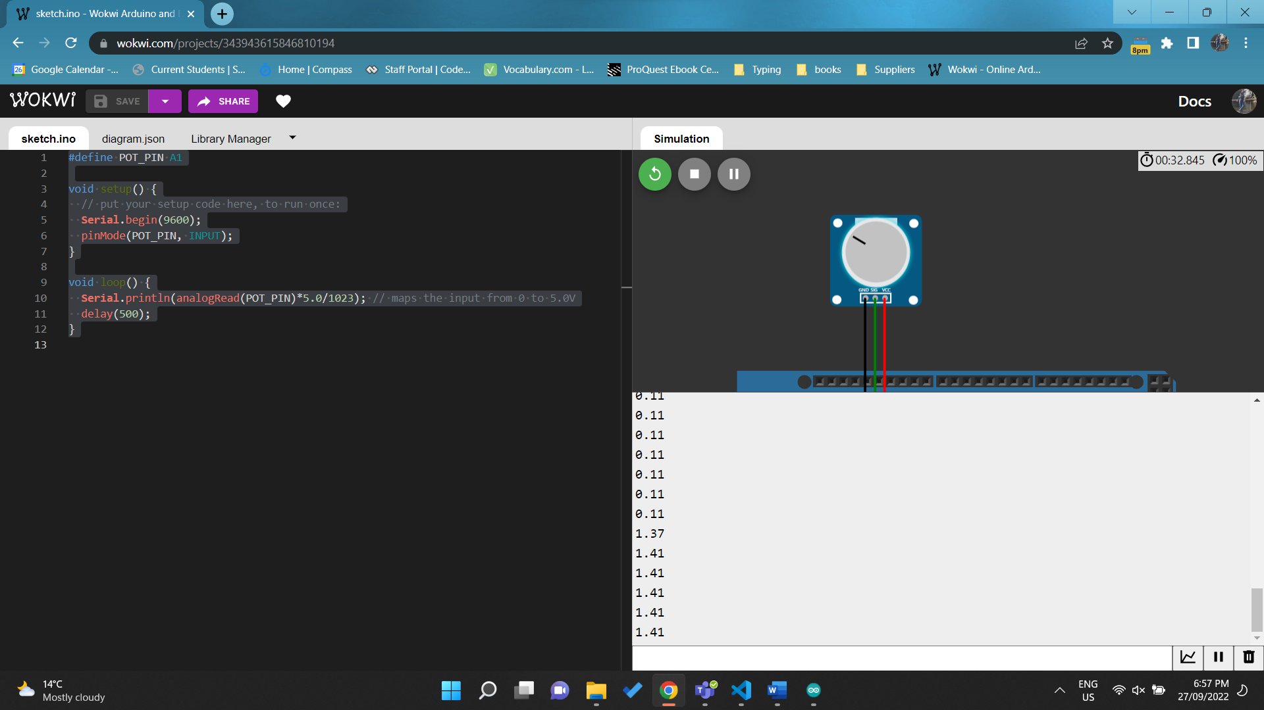

<https://wokwi.com/projects/343943615846810194>

Q3. Store input from the serial monitor using EEPROM and only print from EEPROM if the single input contains exactly 9 integers every time some new characters are typed into the serial monitor. (Require demonstration)

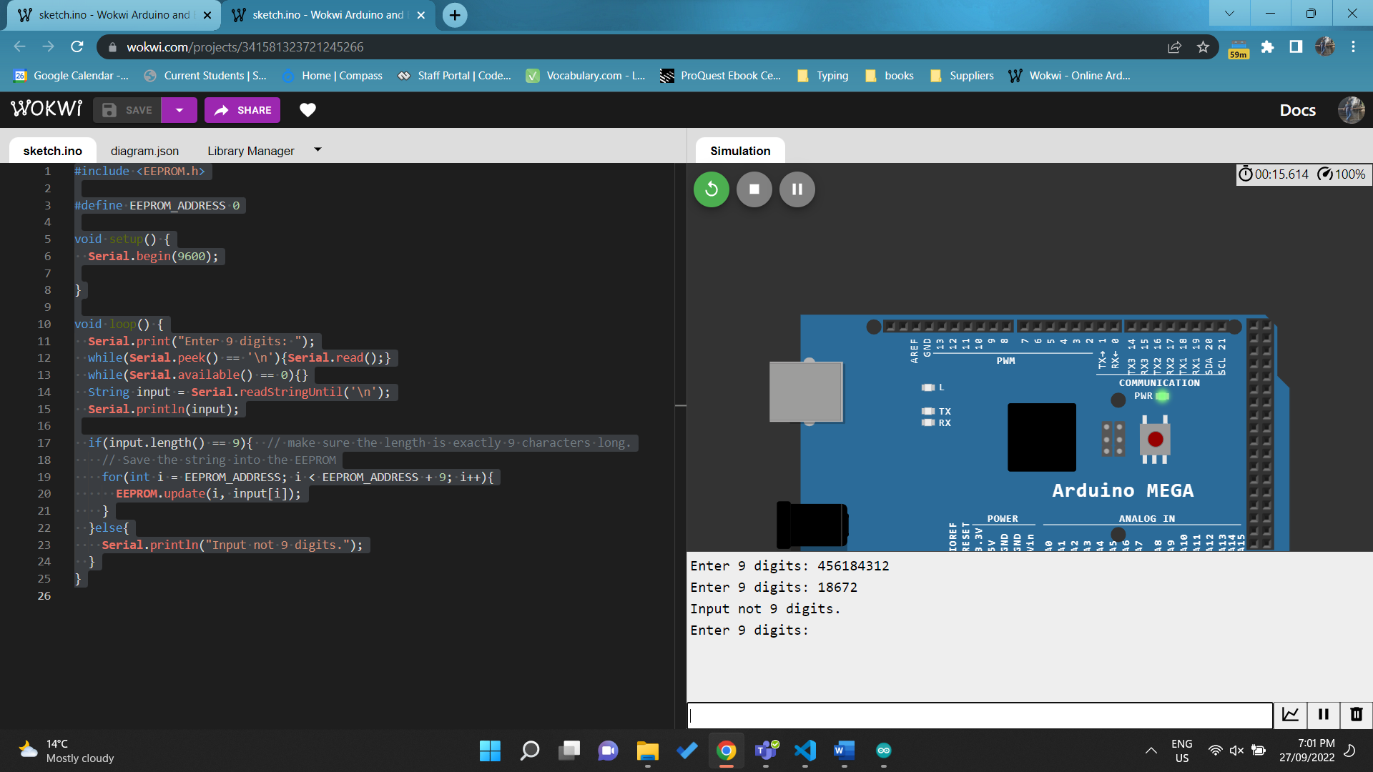

<https://wokwi.com/projects/341581323721245266>

Q4. Write a program that turns on the LED when the push button is pressed and turns it off when the push button is pressed again and so on. Every time the push button is pressed, the state of LED is changed between ON and OFF. You are required to store this state of change with EEPROM so that in the rare event of a power reset, the previous state of LED can be restored. (Require demonstration)

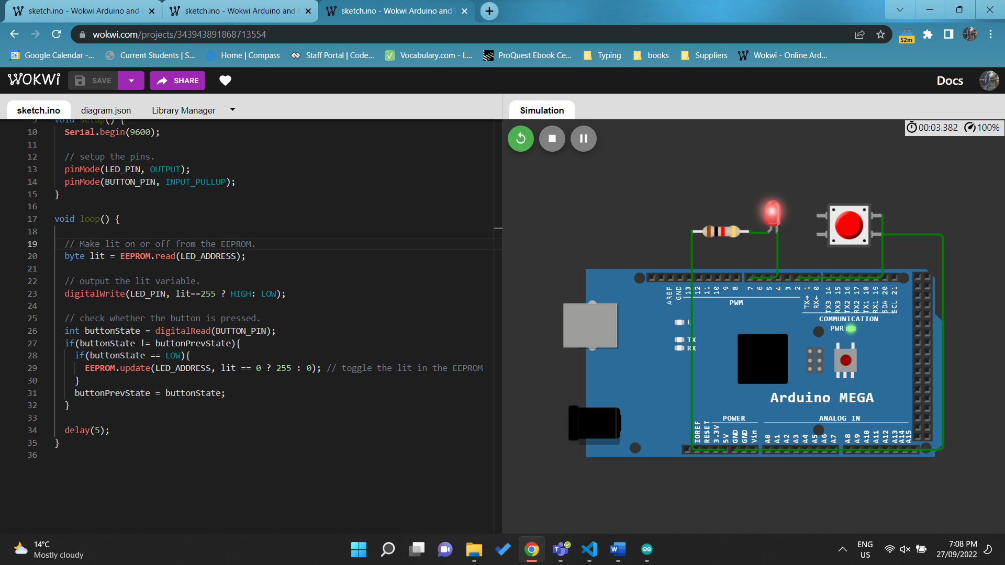 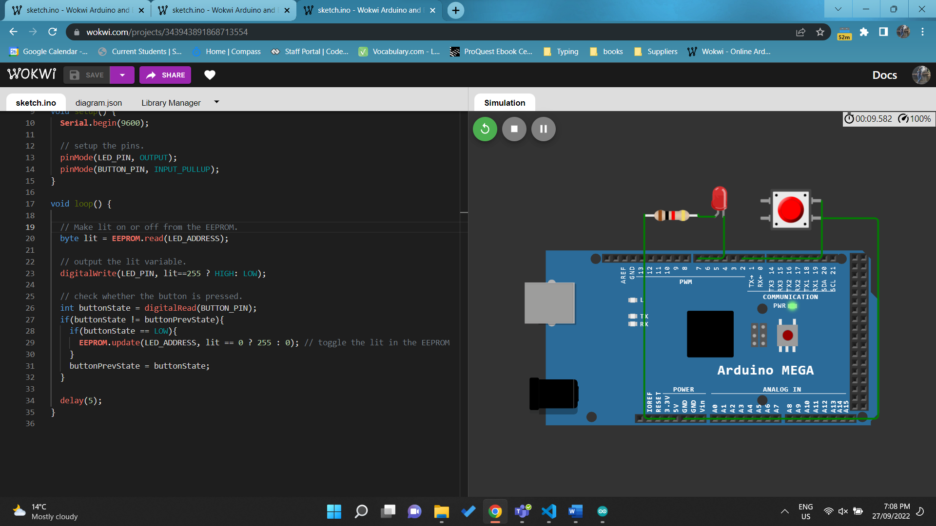

<https://wokwi.com/projects/343943891868713554>

# Pass Borderline Task 6

Q1.Write a simple program to blink the LED every 5 second using timer interrupts (Do not use delay, millis, micros ) . (Require demonstration)

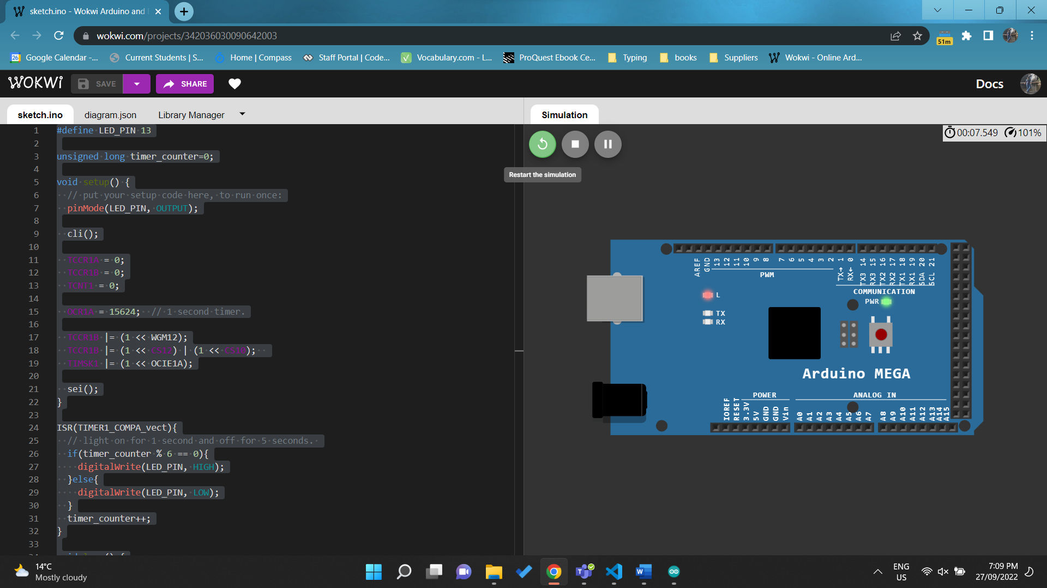 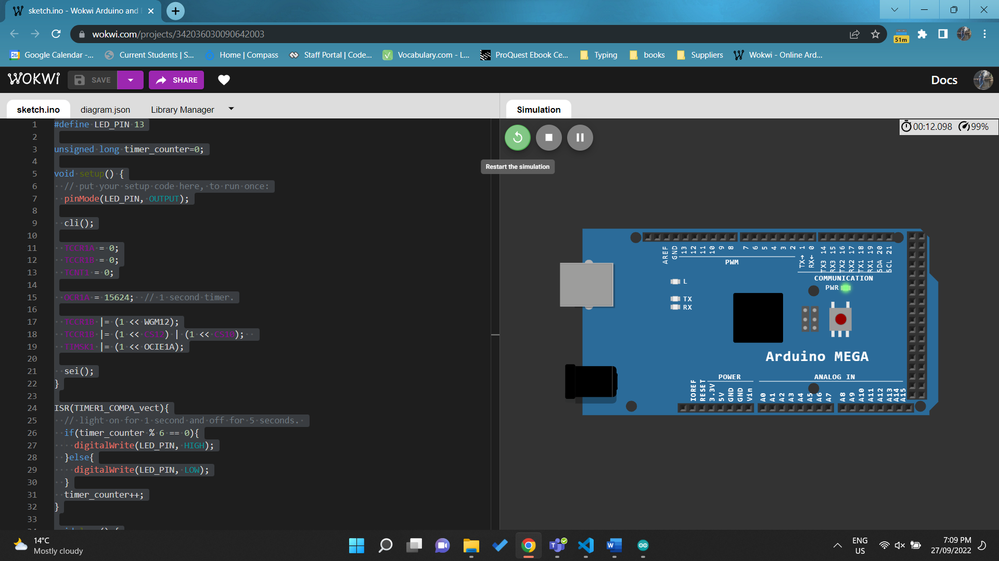

<https://wokwi.com/projects/342036030090642003>

Q2. Write a simple program to blink the inbuilt LED every 500 milliseconds. Connect two buttons to the Arduino (Button A & Button B) When A is pressed millis value should be printed in the serial monitor and when the B is pressed micros value should be printed in the serial monitor. (Use hardware interrupts) . (Require demonstration)

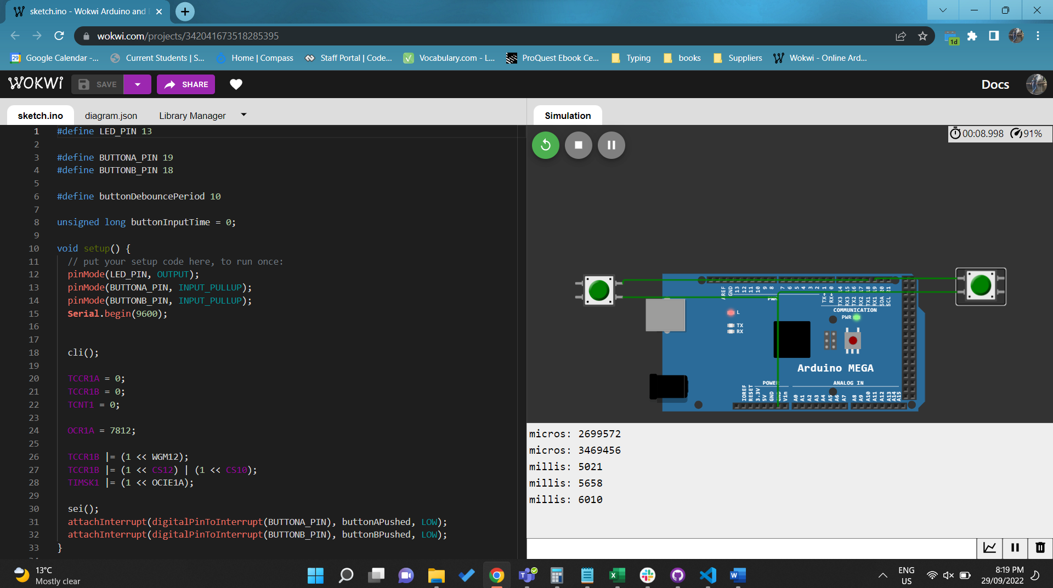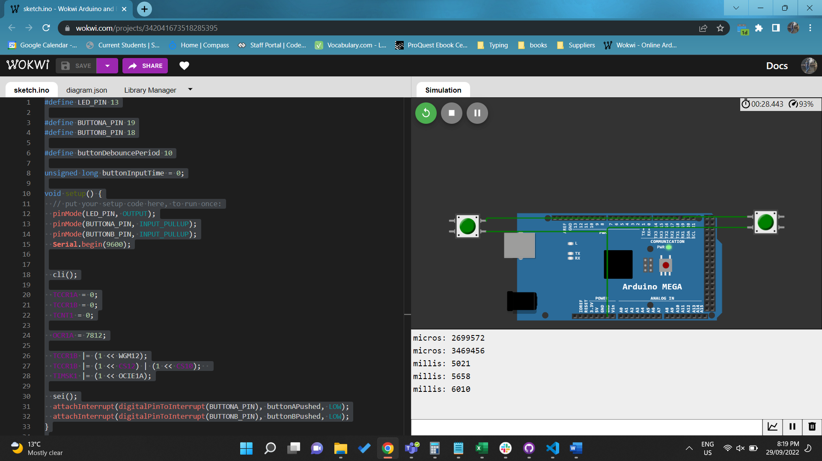

<https://wokwi.com/projects/342041673518285395>

Q3. Write a program to display “I love Swinburne” in the LED matrix. When the external button is pressed it should display your name. The text should move from left to right continuously.(Use LED Dot Matrix MA7219 and interrupts). (Require demonstration)

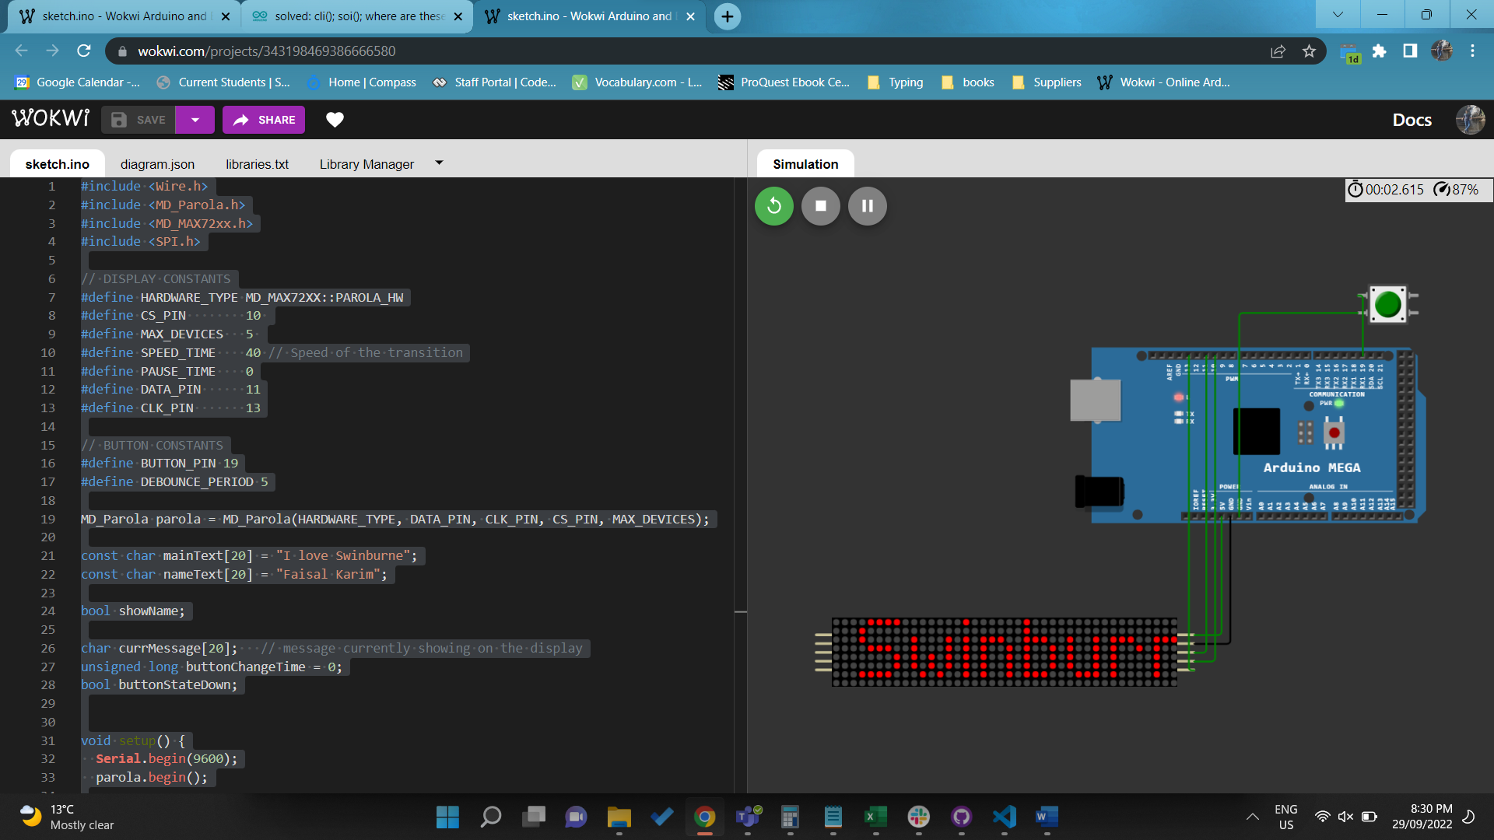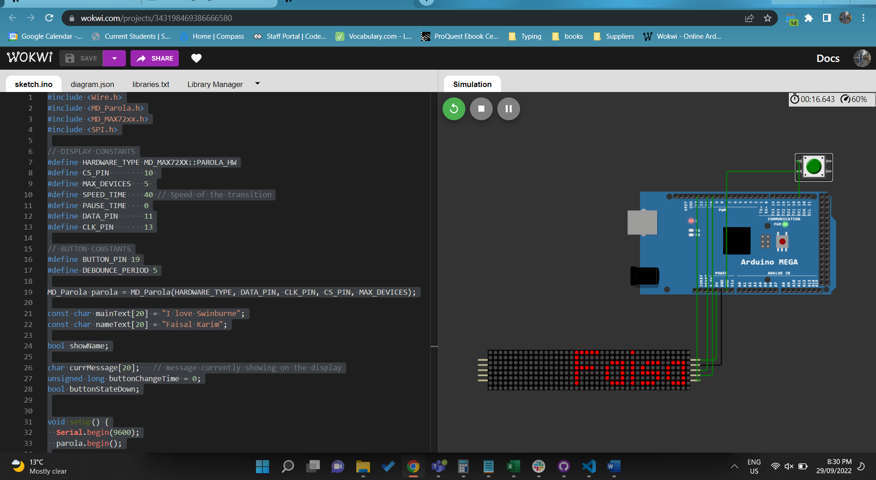

<https://wokwi.com/projects/343198469386666580>

# Pass Plus Task

Q1. To design digital clock with few features. Connect OLED display to Arduino. Write program to display analog and digital clocks. At the beginning, the clock is set up using serial. A real time clock (RTC) module can be added as well. (Require demonstration)

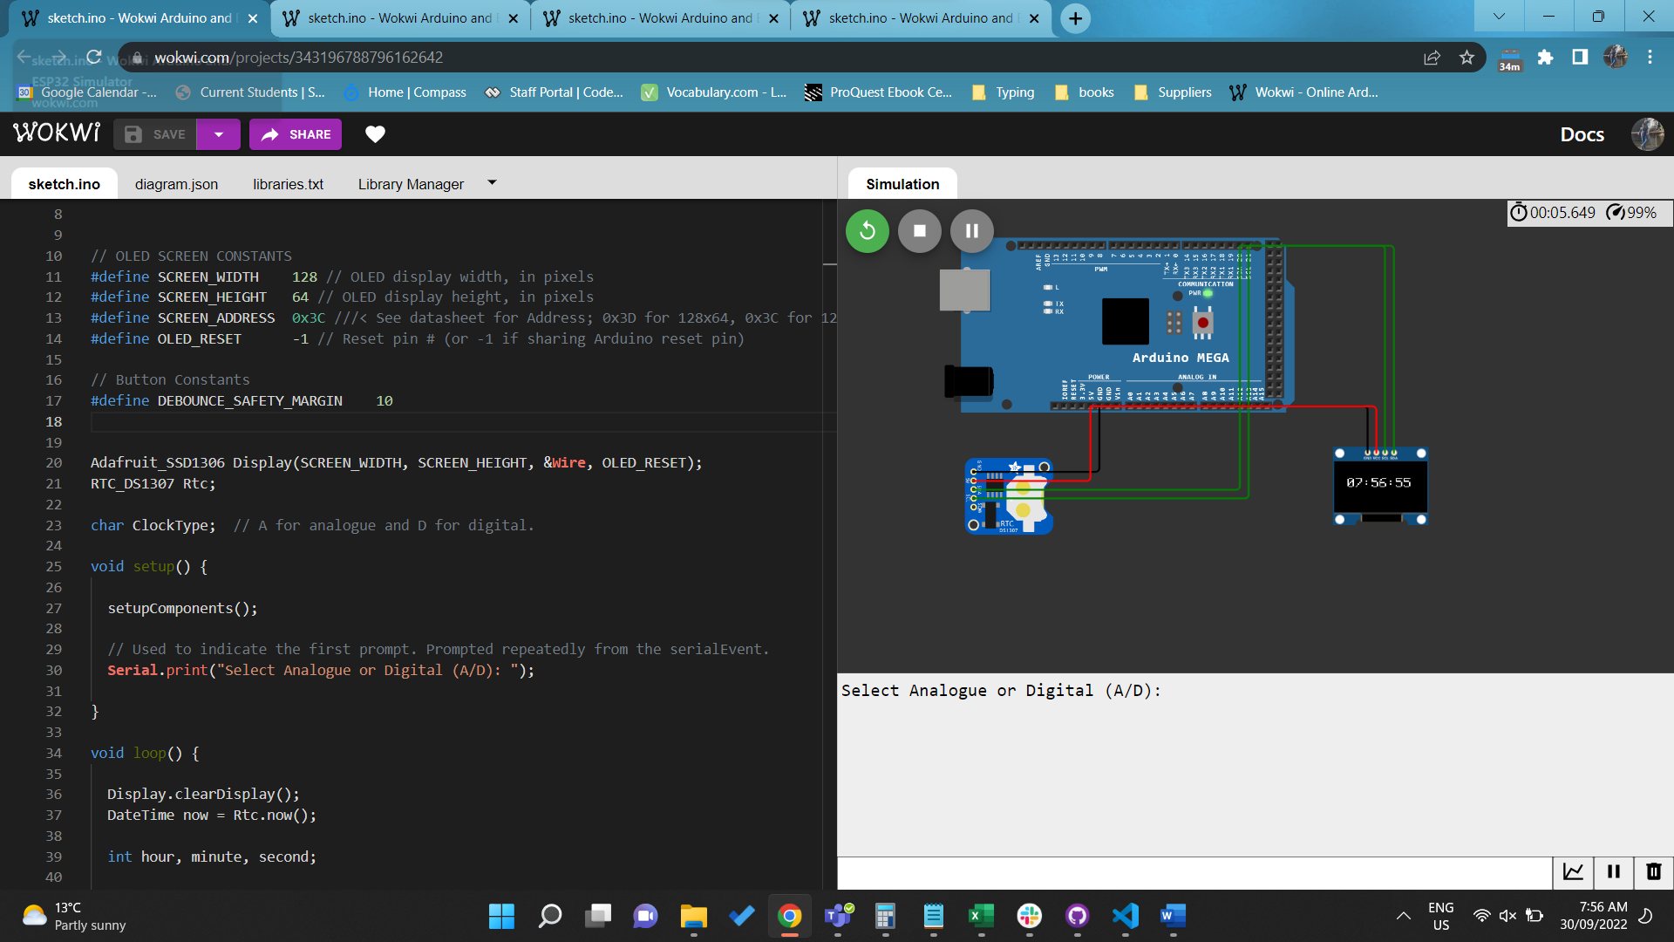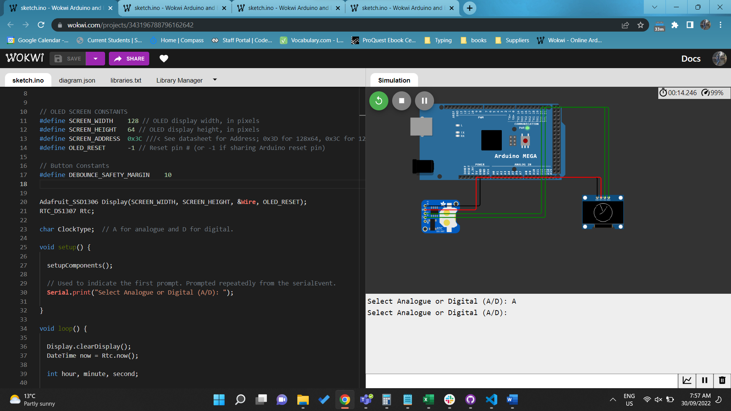

<https://wokwi.com/projects/343196788796162642>

Q2. To design LED matrix with few features. Make a proper connection for 8×8 LED Matrix with resistors to the microcontroller. The LED matrix have to be constructed manually by using 64 units of LED as 8×8 LED Matrix. Display your name and scroll from right to left continuously. (Require demonstration)

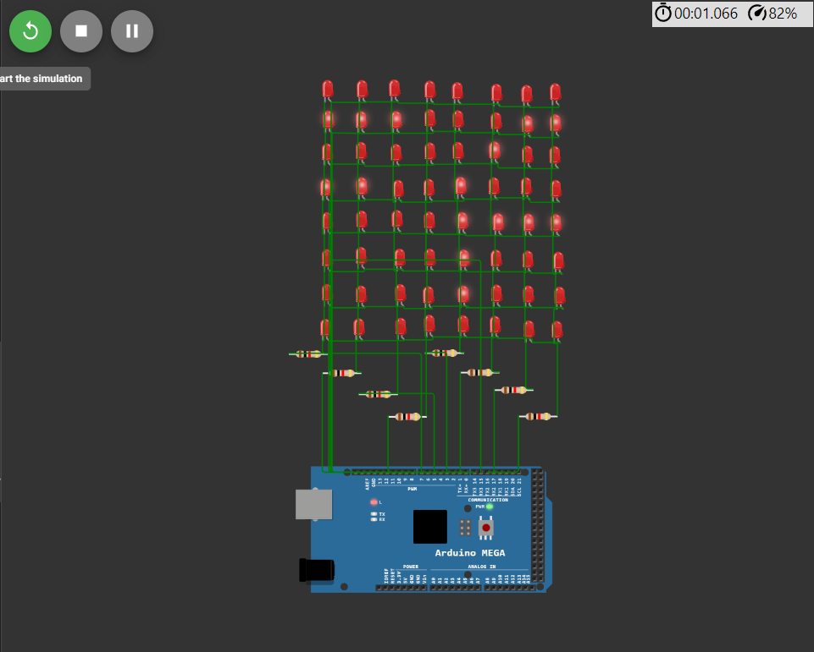

<https://wokwi.com/projects/344174479409152596>

# Credit Task

Q1. Continuing from Pass Plus Task 1 for designing digital clock with few features. Connect to a push button. Use the hardware interrupt to detect the button. If the button is pressed for certain seconds, it will convert to a stopwatch or back to be digital clock. While as stopwatch, the same button is used to start/stop the stopwatch (Require demonstration)

// Enter A or D (UpperCase) to switch between Analogue or Digital, respectively.

// This can be done at any stage of the solution; it can be changed later.

// default is the digital clock.

// Hold the button (or key 5 on your keyboard) for 5 seconds to swtich between

// display screen (Clock, Timer).

// On the Timer screen, short press (<5 sec) the button to start and stop the timer

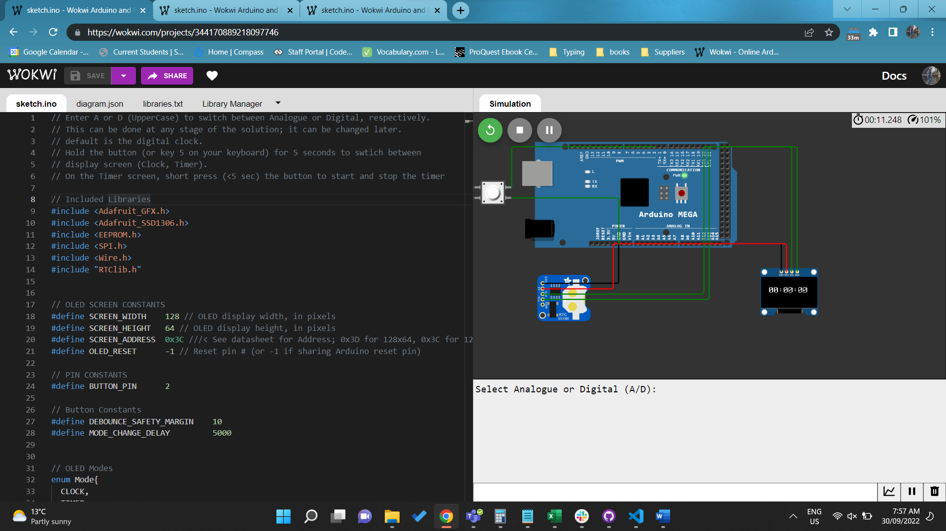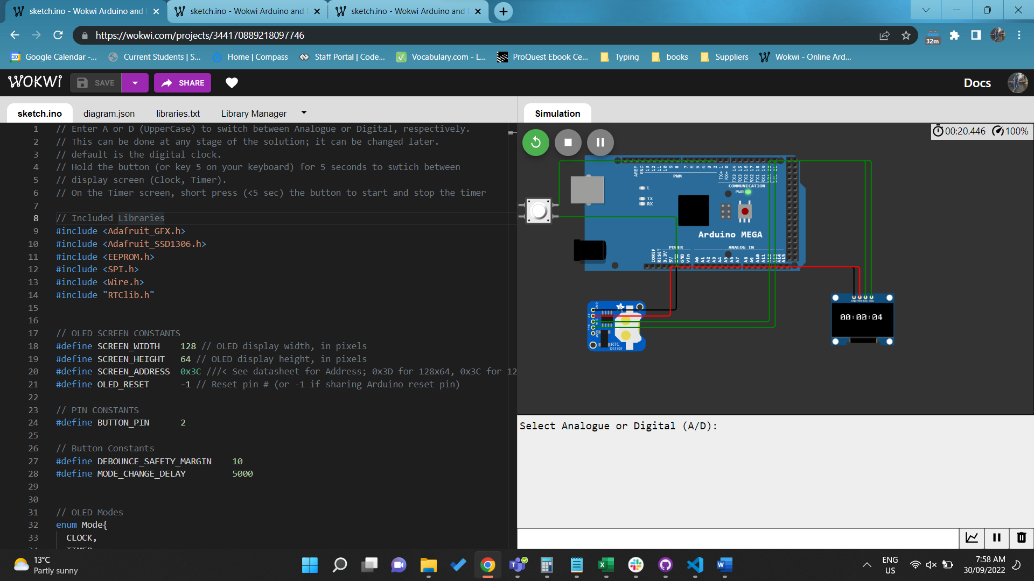

<https://wokwi.com/projects/344170889218097746>

Q2. Continuing from Pass Plus Task 2 for designing LED matrix with few features. Use the serial for allowing change the text of the display and save it to memory. (Require demonstration)

// Enter text in the serial monitor to display on the LED matrix.

// This text can be changed at any time from the serial monitor.

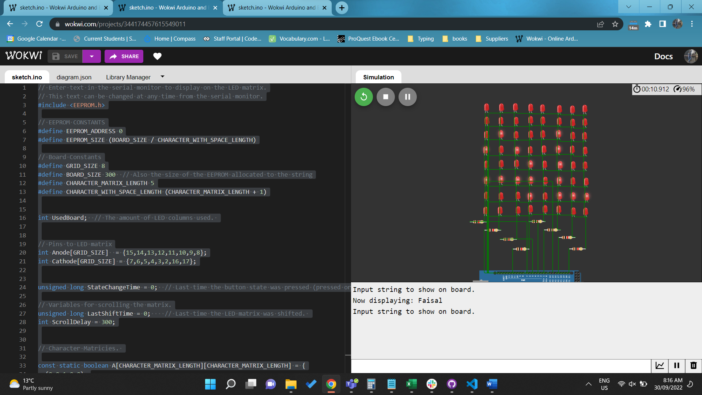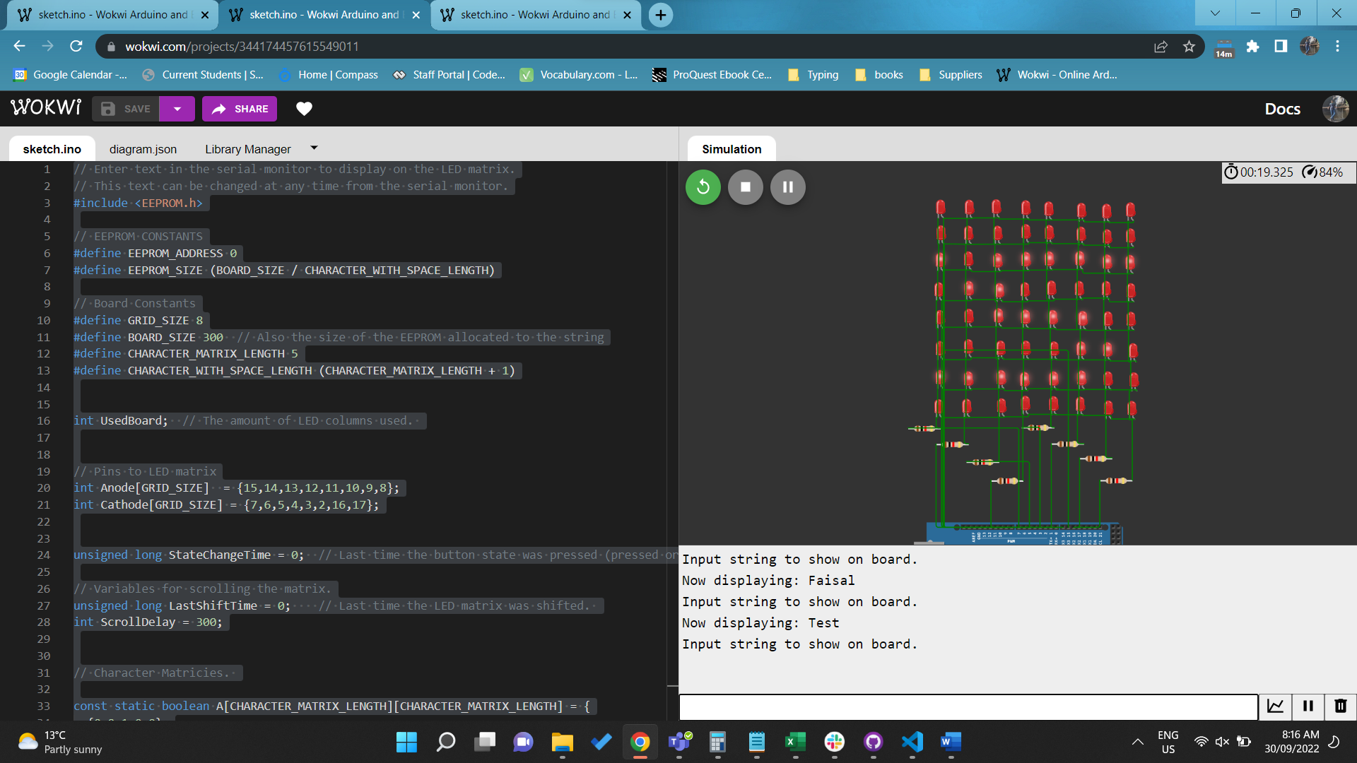

<https://wokwi.com/projects/344174457615549011>

# Distinction Task

Q1. Continuing from Credit Task 1 for designing digital clock with few features. Using the same button to have additional feature to set alarm system. Connect to a speaker for the output of the alarm. (Require demonstration)

// Enter A or D (UpperCase) to switch between Analogue or Digital, respectively.

// This can be done at any stage of the solution; it can be changed later.

// default is the digital clock.

// Hold the button (or key 5 on your keyboard) for 5 seconds to swtich between

// display screen (Clock, Timer, Alarm).

// On the Timer screen, short press (<5 sec) the button to start and stop the timer

// on the Alarm scree, hold the button for 2sec but less than 5sec to switch

// between set hour, set minute and display alarm time state.

// short press (<2 sec) on the set hour state will increment the alarm hour.

// short press (<2 sec) on the set minute state will increment the alarm minute.

// short press (<2 sec) on the display alarm state will toggle the alarm on and off.

// the alarm hour and minute are saved in the EEPROM.

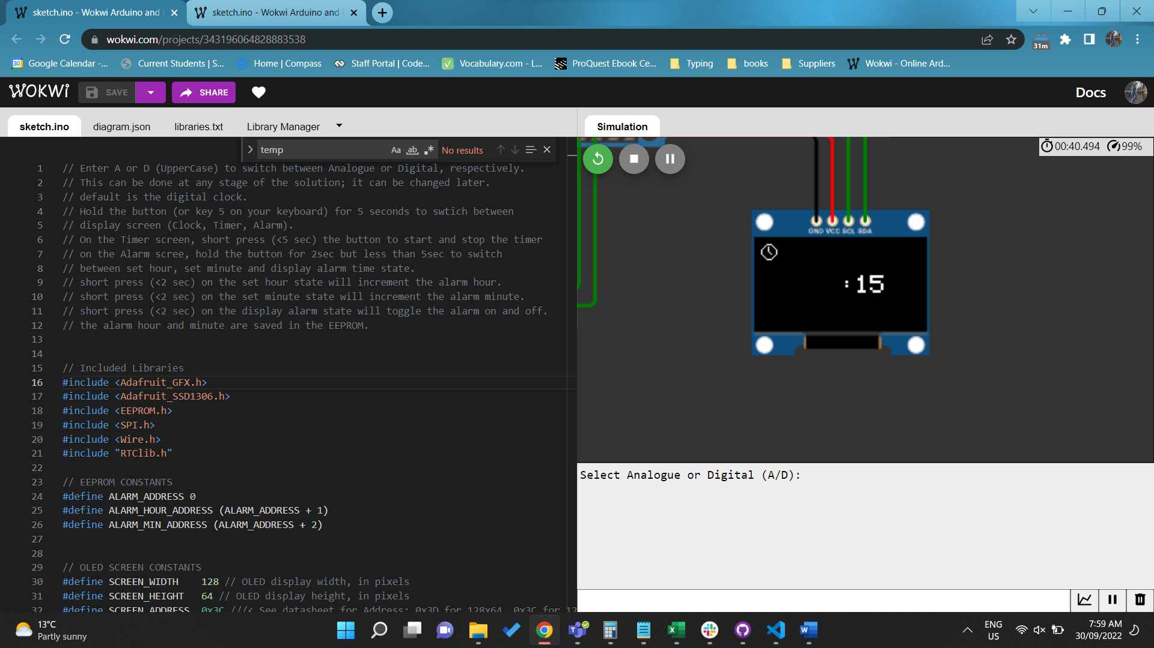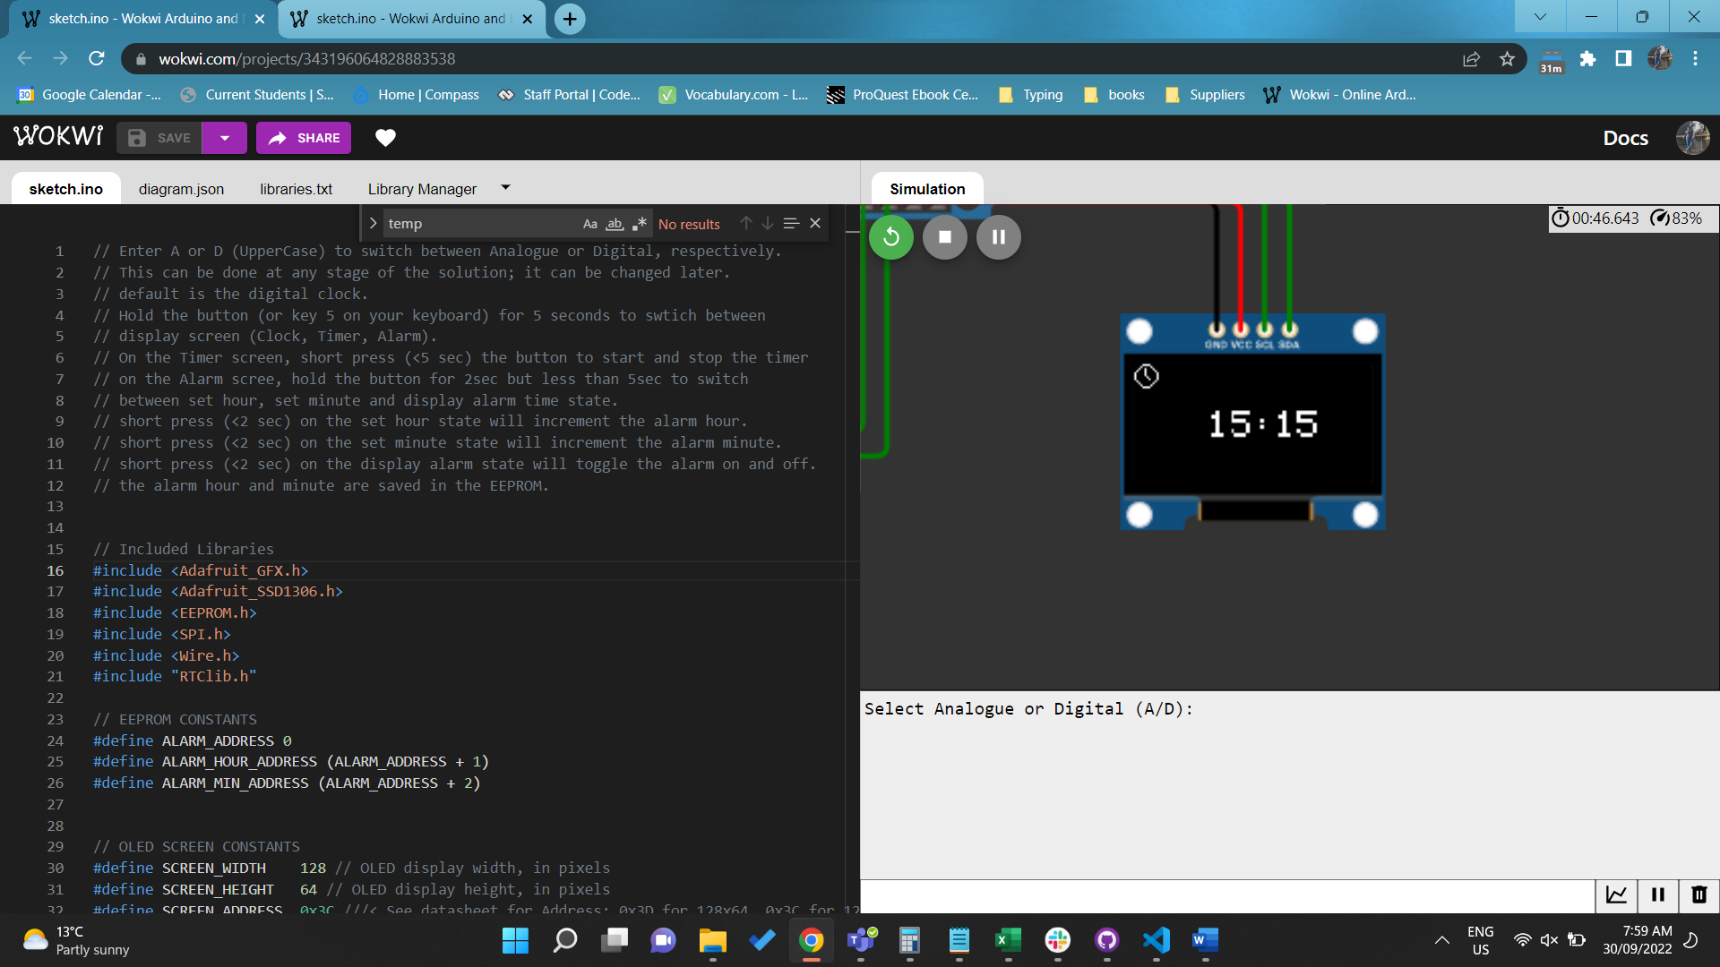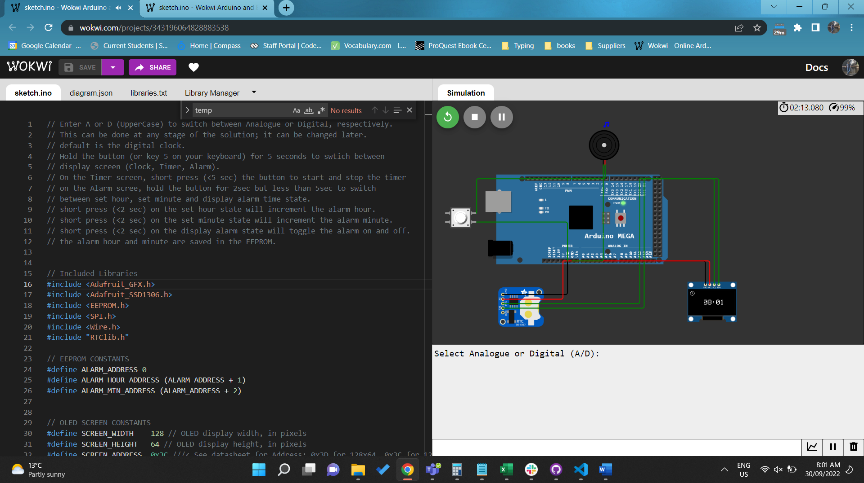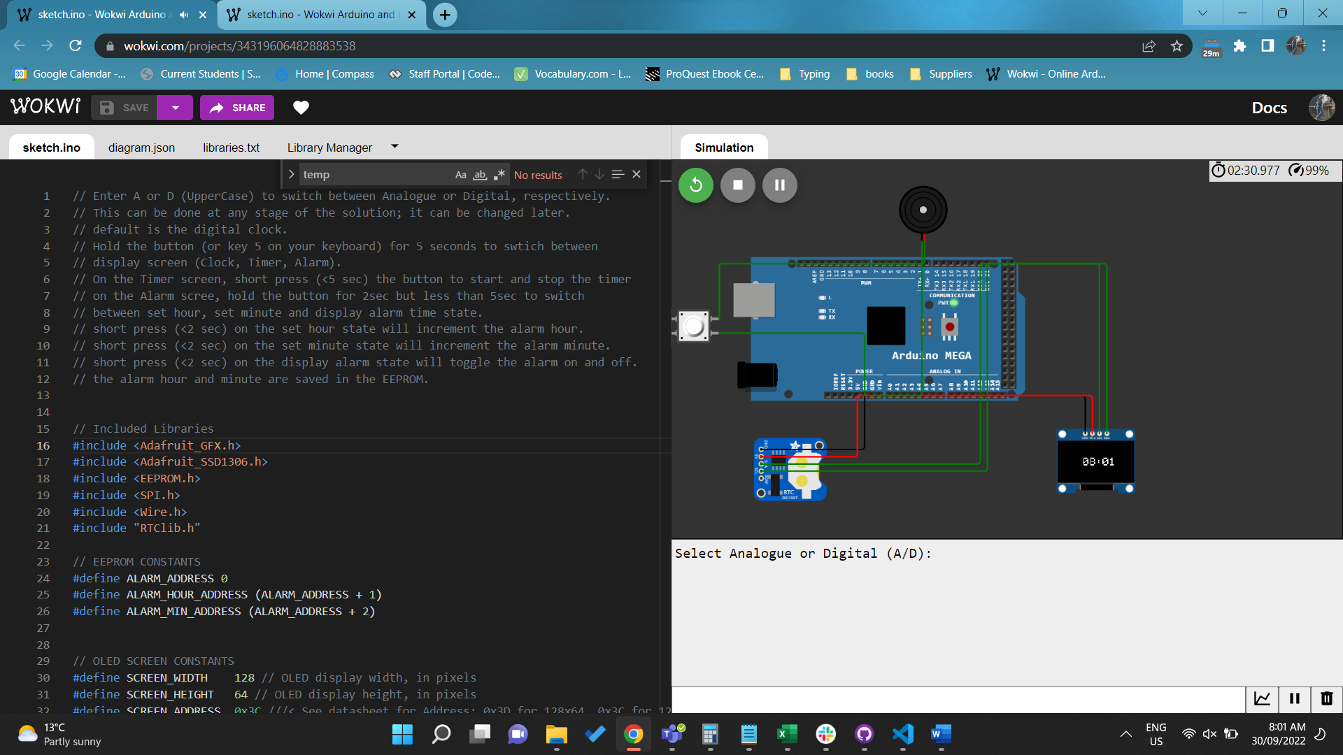

<https://wokwi.com/projects/343196064828883538>

Q2. Continuing from Credit Task 2 for designing LED matrix with few features. Connect the pushbutton to the embedded system. Add additional feature with the button. If button press for 1 second or less, the text will moving from left to right. If press for button press more than 2 seconds, the text will move from right to left. . (Require demonstration)

// Enter text in the serial monitor to display on the LED matrix.

// This text can be changed at any time from the serial monitor.

// press the button (or key 5 on your keyboard) for <=1 sec, to move the

// text from left to right.

// press the button for > 2 to move the text from right to left.

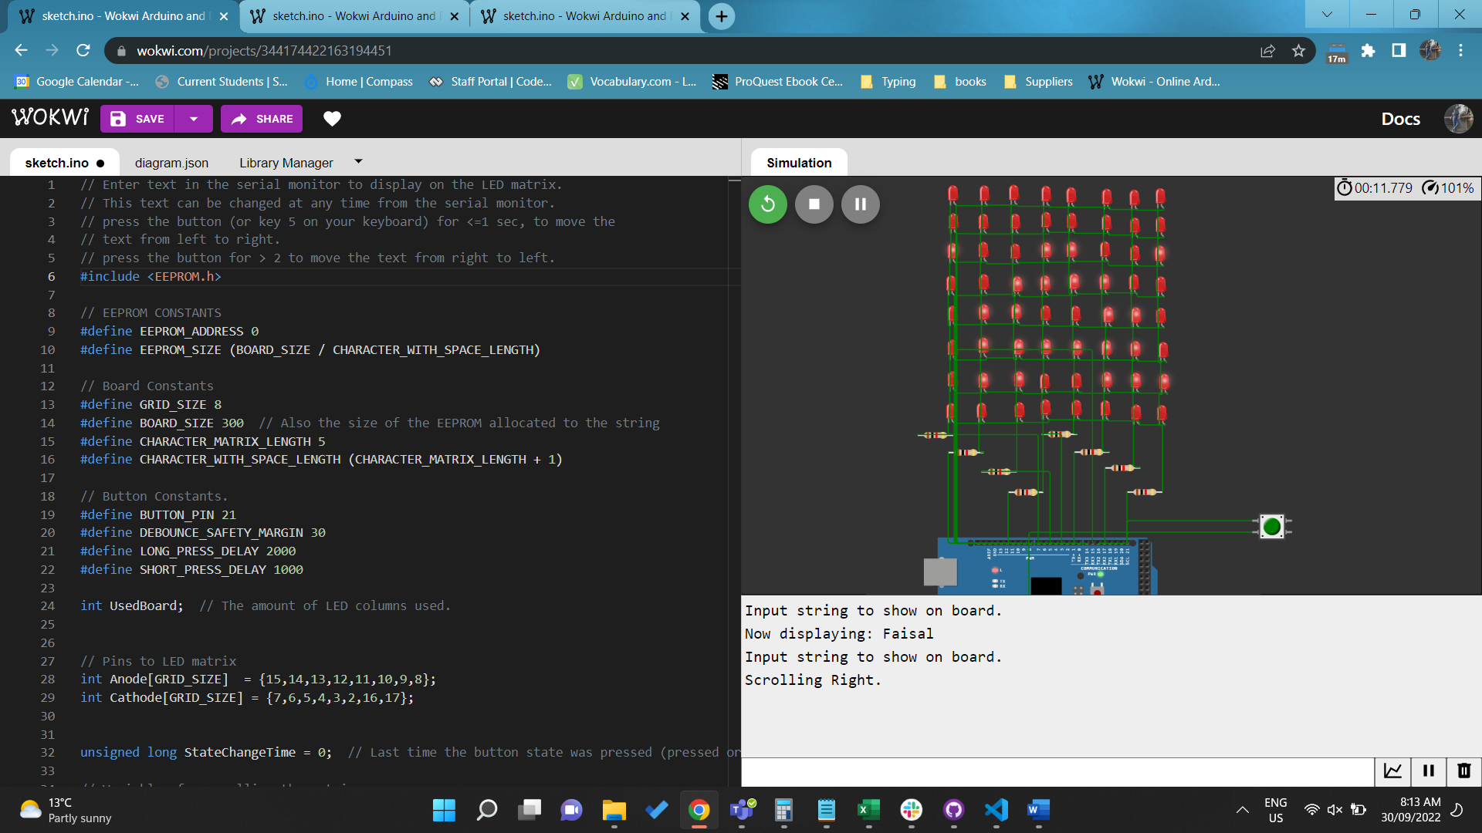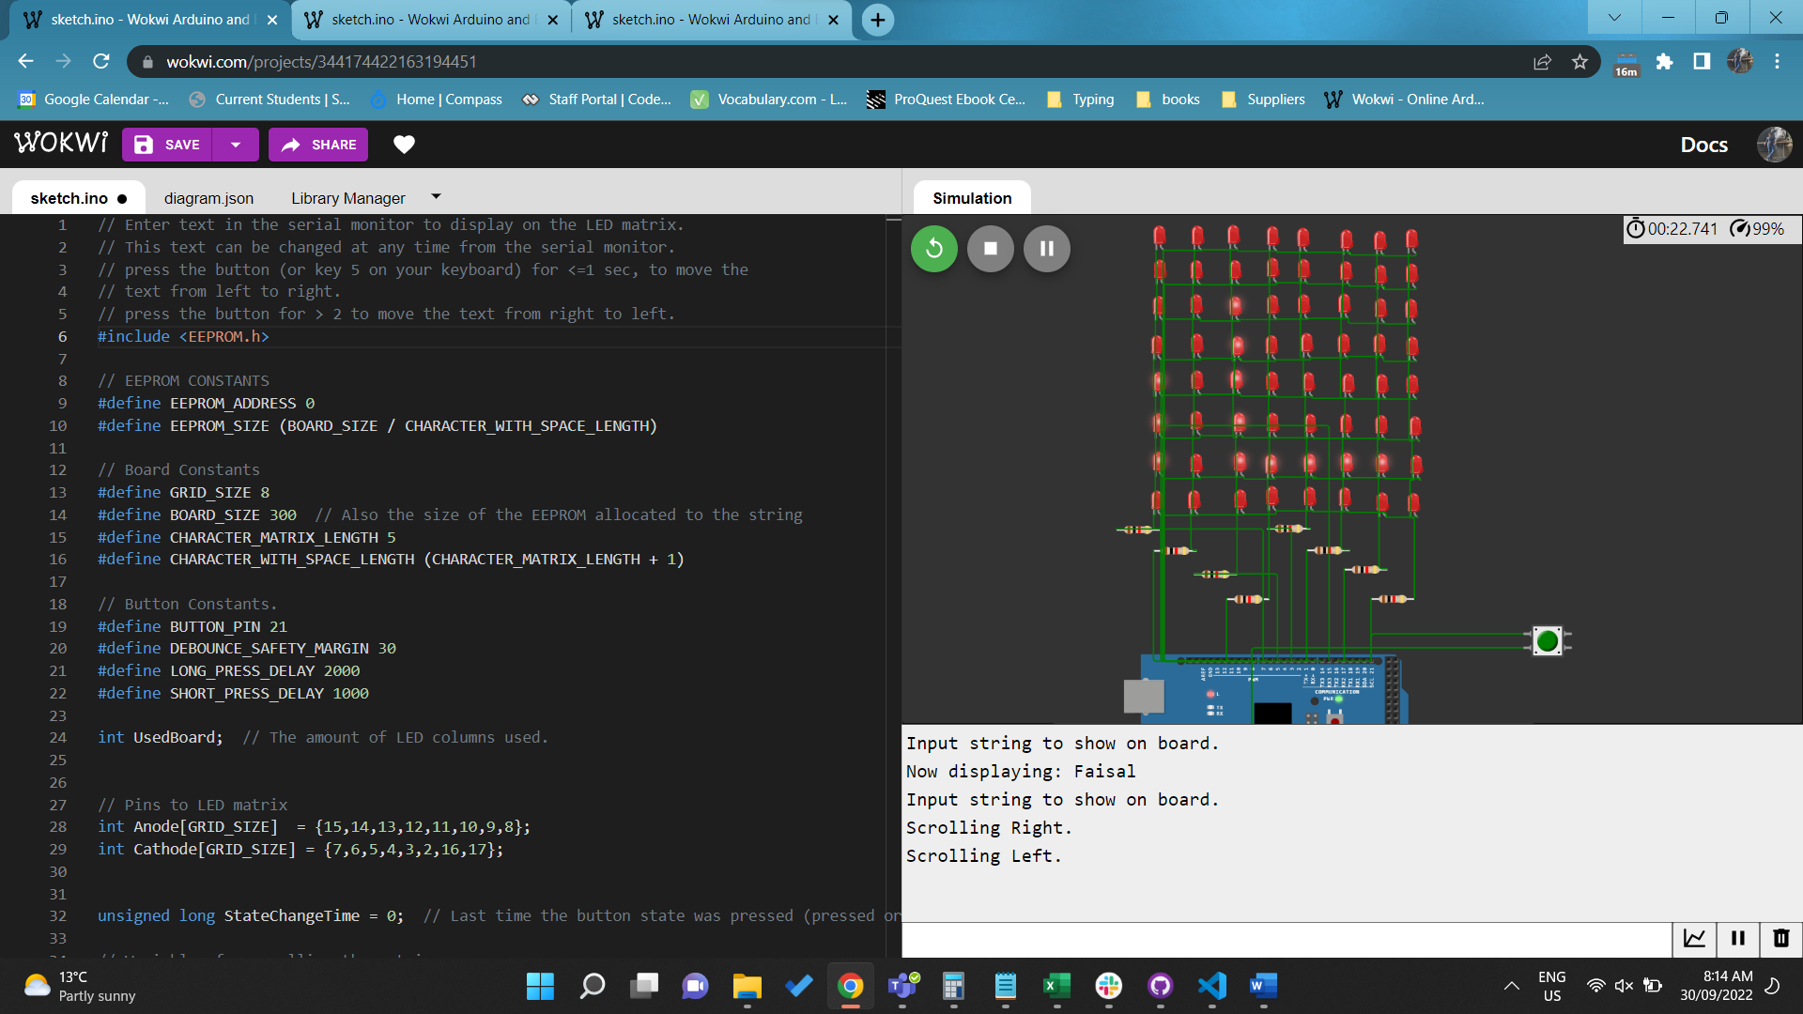

<https://wokwi.com/projects/344174422163194451>

# High Distinction Task

Q1. Continuing from Distinction Task 1 for designing digital clock with few features. Connect the temperature sensor to the microcontroller. Using previous button to have additional feature to turn on/off displaying temperature on the OLED display. If it is activated, read temperature sensor and display on OLED display. Apply three threshold (cold, medium and hot) and connect to LEDs for RGB LED as the output (Require demonstration)

// Enter A or D (UpperCase) to switch between Analogue or Digital, respectively.

// This can be done at any stage of the solution; it can be changed later.

// default is the digital clock.

// Hold the button (or key 5 on your keyboard) for 5 seconds to swtich between

// display screen (Clock, Timer, Alarm).

// On the Clock screen, short press (<5 sec) the button to toggle the temp display.

// On the Timer screen, short press (<5 sec) the button to start and stop the timer

// on the Alarm scree, hold the button for 2sec but less than 5sec to switch

// between set hour, set minute and display alarm time state.

// short press (<2 sec) on the set hour state will increment the alarm hour.

// short press (<2 sec) on the set minute state will increment the alarm minute.

// short press (<2 sec) on the display alarm state will toggle the alarm on and off.

// the alarm hour and minute are saved in the EEPROM.

// The temp is also indicated using LEDs. For temp >25, it is treated as hot therefore,

// the red led will turn on. Temp that is >18  and <=25 is taken as warm and the amber

// light will be on. For temps <= 18, the green light will be on.

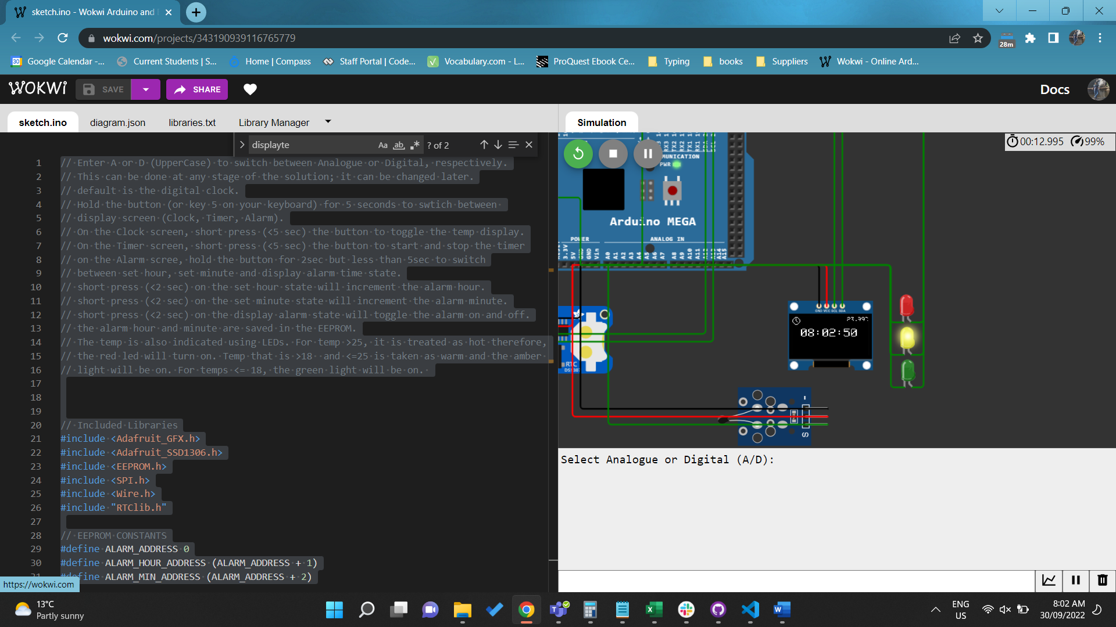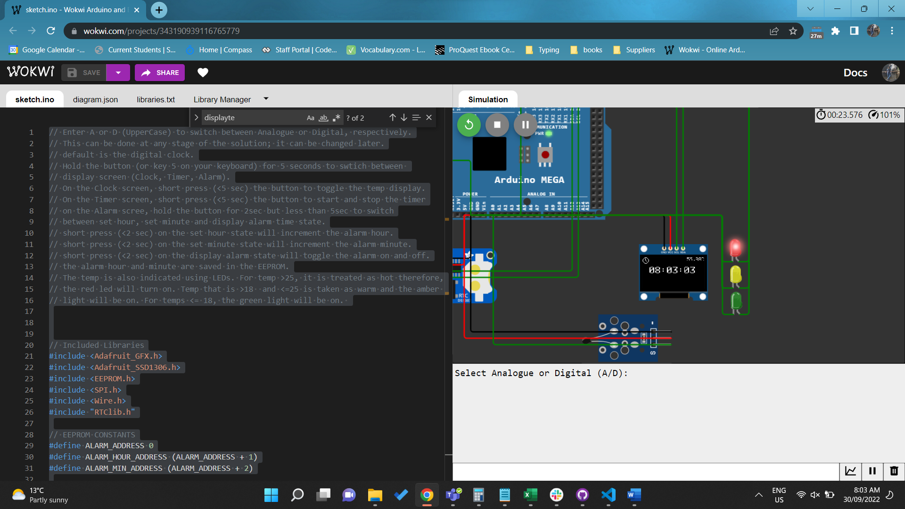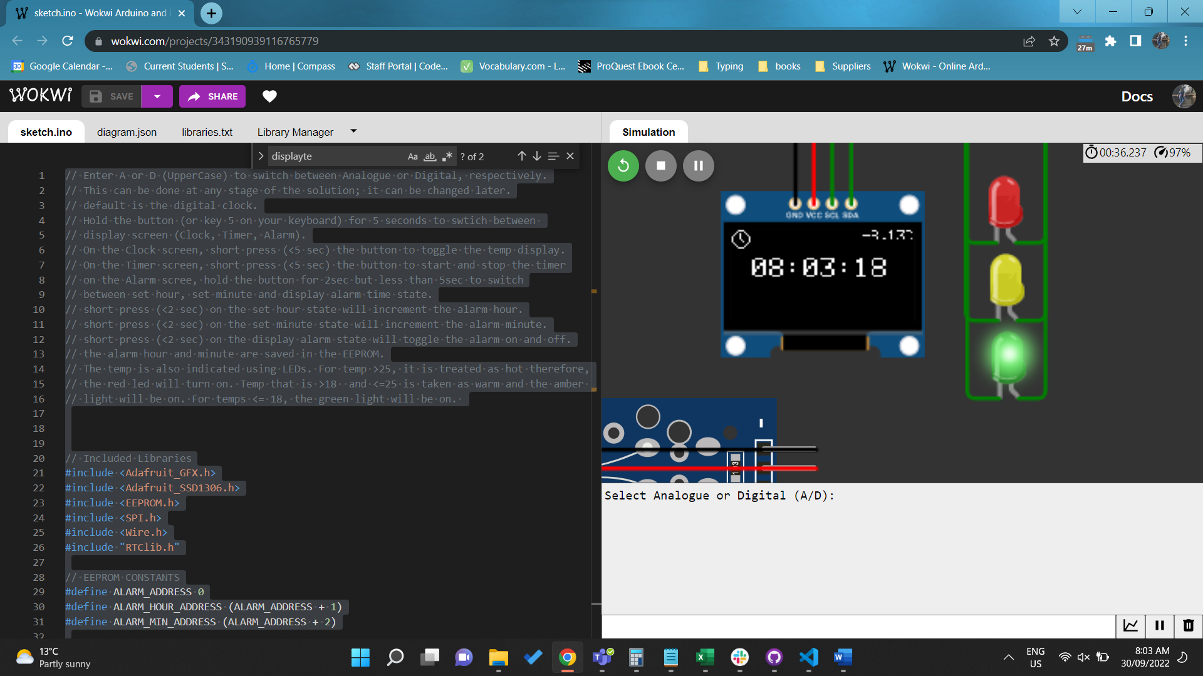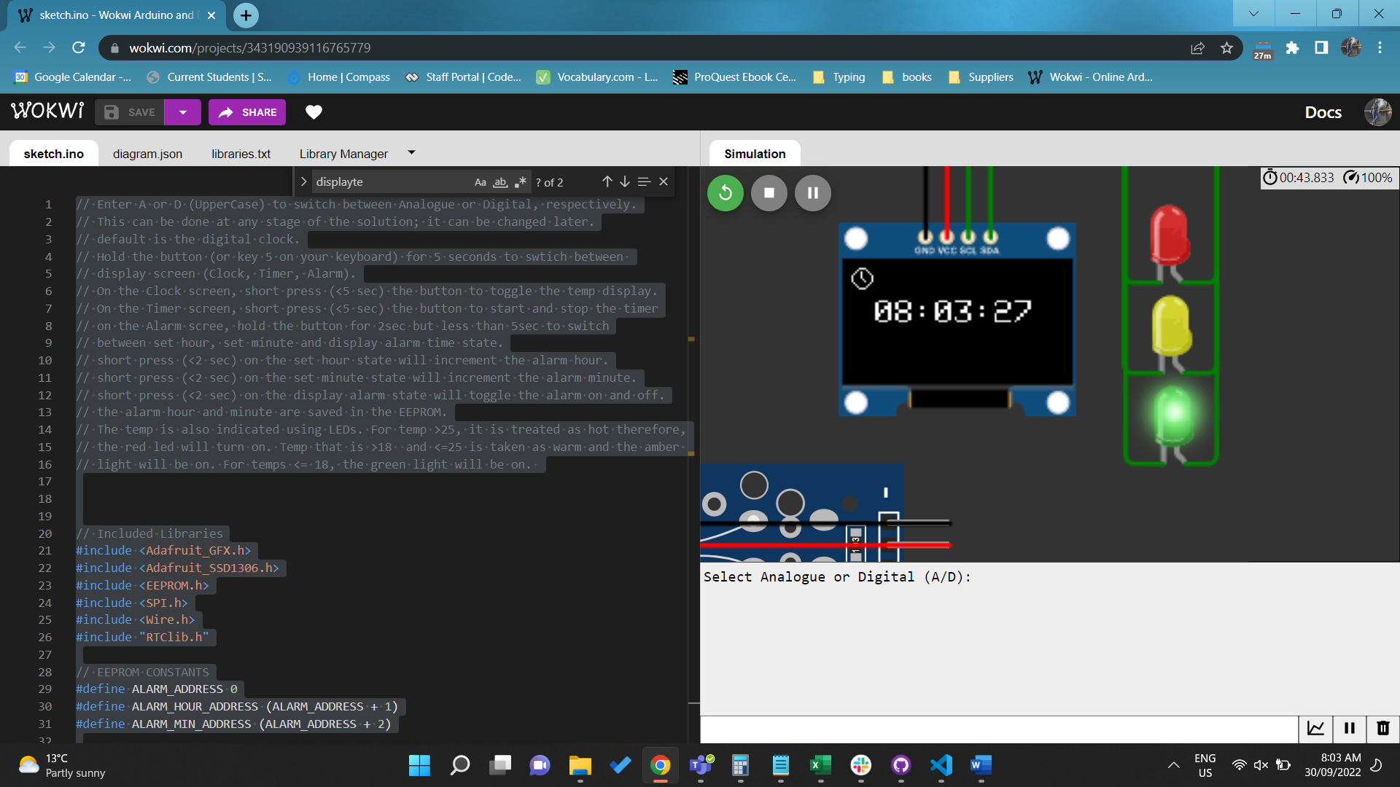

<https://wokwi.com/projects/343190939116765779>

Q2. Continuing from Credit Task 2 for designing LED matrix with few features. Additional features is need to be added with the same pushbutton to change up to 3 modes for speed of the moving text includes slow, medium and fast. (Require demonstration)

// Enter text in the serial monitor to display on the LED matrix.

// This text can be changed at any time from the serial monitor.

// press the button (or key 5 on your keyboard) for <=1 sec, to move the

// text from left to right.

// press the button for > 2 to move the text from right to left.

// press the button >1 and <= 2, to change between three speed modes.

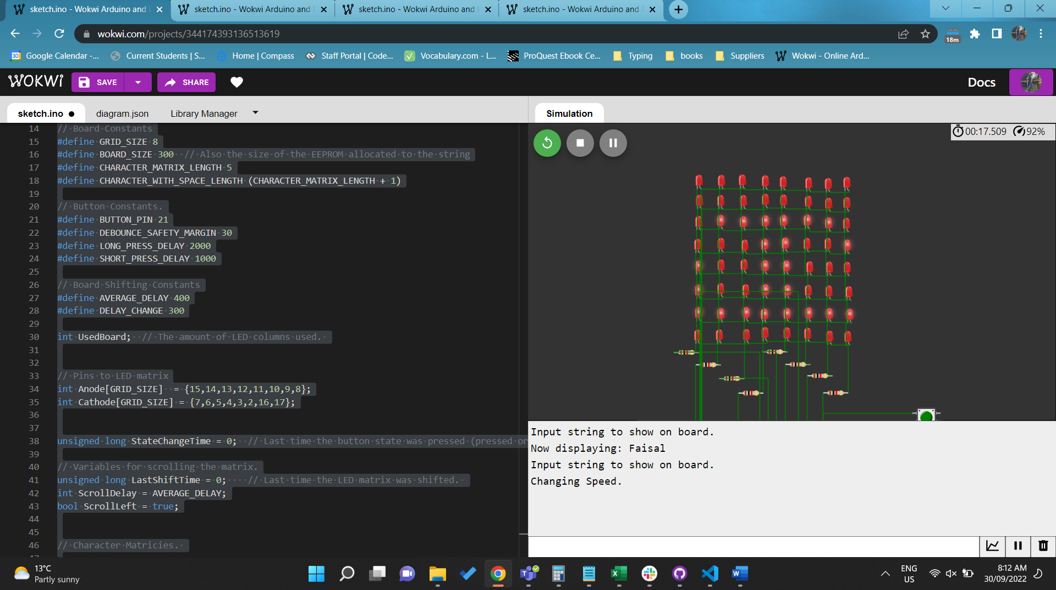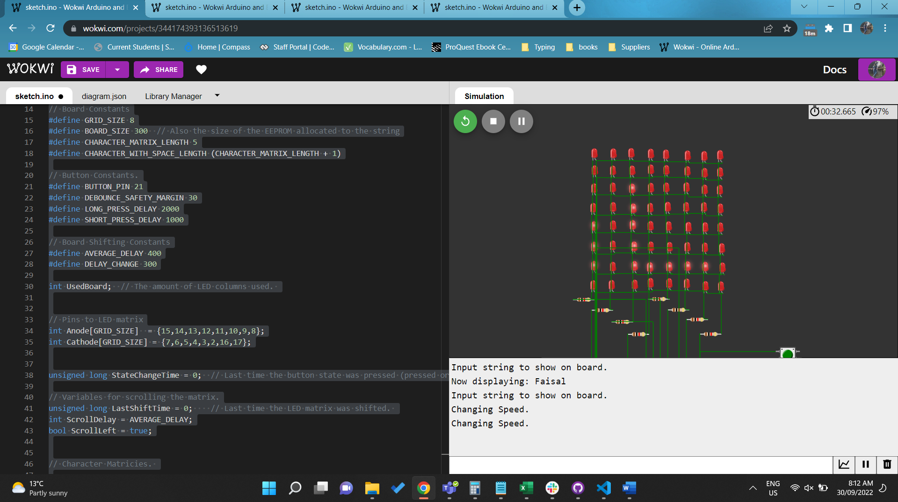

<https://wokwi.com/projects/344174393136513619>